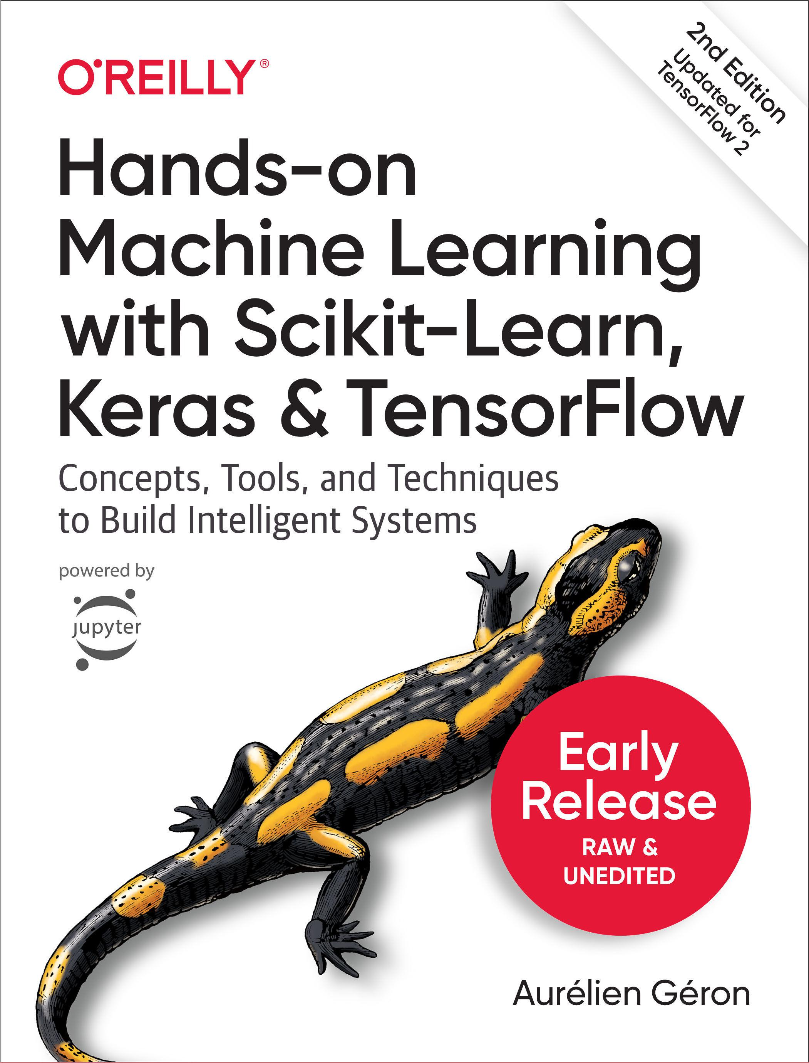

**SECOND EDITION**



**Hands-on Machine Learning with Scikit-Learn, Keras, and TensorFlow**

***Concepts, Tools, and Techniques to Build Intelligent Systems***

***Aurélien Géron***



Beijing  Boston  Farnham  Sebastopol  Tokyo

**Hands-on Machine Learning with Scikit-Learn, Keras, and TensorFlow** by Aurélien Géron

Copyright © 2019 Aurélien Géron. All rights reserved. Printed in the United States of America.

Published by O’Reilly Media, Inc., 1005 Gravenstein Highway North, Sebastopol, CA 95472.

O’Reilly books may be purchased for educational, business, or sales promotional use. Online editions are also available for most titles ([*http://oreilly.com*](http://oreilly.com)). For more information, contact our corporate/institutional sales department: 800-998-9938 or *corporate@oreilly.com*.

|  |  |  |
| --- | --- | --- |
| **Editor:** Nicole Tache |  | **Cover Designer:** Karen Montgomery |
| **Interior Designer:** David Futato | | **Illustrator:** Rebecca Demarest |
| June 2019: | Second Edition |  |

**Revision History for the Early Release**

2018-11-05: First Release

2019-01-24: Second Release

2019-03-07: Third Release

2019-03-29: Fourth Release

2019-04-22: Fifth Release

See [*http://oreilly.com/catalog/errata.csp?isbn=9781492032649*](http://oreilly.com/catalog/errata.csp?isbn=9781492032649) for release details.

The O’Reilly logo is a registered trademark of O’Reilly Media, Inc. *Hands-on Machine Learning with* *Scikit-Learn, Keras, and TensorFlow*, the cover image, and related trade dress are trademarks of O’ReillyMedia, Inc.

While the publisher and the author have used good faith efforts to ensure that the information and instructions contained in this work are accurate, the publisher and the author disclaim all responsibility for errors or omissions, including without limitation responsibility for damages resulting from the use of or reliance on this work. Use of the information and instructions contained in this work is at your own risk. If any code samples or other technology this work contains or describes is subject to open source licenses or the intellectual property rights of others, it is your responsibility to ensure that your use thereof complies with such licenses and/or rights.

978-1-492-03264-9 [LSI]

**Table of Contents**



**Preface. . . . . . . . . . . . . . . . . . . . . . . . . . . . . . . . . . . . . . . . . . . . . . . . . . . . . . . . . . . . . . . . . . . . . . .****xi**



**Part I.** **The Fundamentals of Machine Learning**

**1.** **The Machine Learning Landscape. . . . . . . . . . . . . . . . . . . . . . . . . . . . . . . . . . . . . . . . . . . . . 3**

What Is Machine Learning? 4

Why Use Machine Learning? 4

Types of Machine Learning Systems 8

Supervised/Unsupervised Learning 8

Batch and Online Learning 15

Instance-Based Versus Model-Based Learning 18

Main Challenges of Machine Learning 24

Insufficient Quantity of Training Data 24

Nonrepresentative Training Data 26

Poor-Quality Data 27

Irrelevant Features 27

Overfitting the Training Data 28

Underfitting the Training Data 30

Stepping Back 30

Testing and Validating 31

Hyperparameter Tuning and Model Selection 32

Data Mismatch 33

Exercises 34

**2.** **End-to-End Machine Learning Project. . . . . . . . . . . . . . . . . . . . . . . . . . . . . . . . . . . . . . . .** **37**

Working with Real Data 38

Look at the Big Picture 39



**iii**

|  |  |
| --- | --- |
| Frame the Problem | 39 |
| Select a Performance Measure | 42 |
| Check the Assumptions | 45 |
| Get the Data | 45 |
| Create the Workspace | 45 |
| Download the Data | 49 |
| Take a Quick Look at the Data Structure | 50 |
| Create a Test Set | 54 |
| Discover and Visualize the Data to Gain Insights | 58 |
| Visualizing Geographical Data | 59 |
| Looking for Correlations | 62 |
| Experimenting with Attribute Combinations | 65 |
| Prepare the Data for Machine Learning Algorithms | 66 |
| Data Cleaning | 67 |
| Handling Text and Categorical Attributes | 69 |
| Custom Transformers | 71 |
| Feature Scaling | 72 |
| Transformation Pipelines | 73 |
| Select and Train a Model | 75 |
| Training and Evaluating on the Training Set | 75 |
| Better Evaluation Using Cross-Validation | 76 |
| Fine-Tune Your Model | 79 |
| Grid Search | 79 |
| Randomized Search | 81 |
| Ensemble Methods | 82 |
| Analyze the Best Models and Their Errors | 82 |
| Evaluate Your System on the Test Set | 83 |
| Launch, Monitor, and Maintain Your System | 84 |
| Try It Out! | 85 |
| Exercises | 85 |

**3.** **Classi€cation. . . . . . . . . . . . . . . . . . . . . . . . . . . . . . . . . . . . . . . . . . . . . . . . . . . . . . . . . . . . .** **87**

|  |  |
| --- | --- |
| MNIST | 87 |
| Training a Binary Classifier | 90 |
| Performance Measures | 90 |
| Measuring Accuracy Using Cross-Validation | 91 |
| Confusion Matrix | 92 |
| Precision and Recall | 94 |
| Precision/Recall Tradeoff | 95 |
| The ROC Curve | 99 |
| Multiclass Classification | 102 |
| Error Analysis | 104 |



**iv** **|** **Table of Contents**

Multilabel Classification 108

Multioutput Classification 109

Exercises 110

**4.** **Training Models. . . . . . . . . . . . . . . . . . . . . . . . . . . . . . . . . . . . . . . . . . . . . . . . . . . . . . . . . . 113**

Linear Regression 114

The Normal Equation 116

Computational Complexity 119

Gradient Descent 119

Batch Gradient Descent 123

Stochastic Gradient Descent 126

Mini-batch Gradient Descent 129

Polynomial Regression 130

Learning Curves 132

Regularized Linear Models 136

Ridge Regression 137

Lasso Regression 139

Elastic Net 142

Early Stopping 142

Logistic Regression 144

Estimating Probabilities 144

Training and Cost Function 145

Decision Boundaries 146

Softmax Regression 149

Exercises 153

**5.** **Support Vector Machines. . . . . . . . . . . . . . . . . . . . . . . . . . . . . . . . . . . . . . . . . . . . . . . . . . 155**

Linear SVM Classification 155

Soft Margin Classification 156

Nonlinear SVM Classification 159

Polynomial Kernel 160

Adding Similarity Features 161

Gaussian RBF Kernel 162

Computational Complexity 163

SVM Regression 164

Under the Hood 166

Decision Function and Predictions 166

Training Objective 167

Quadratic Programming 169

The Dual Problem 170

Kernelized SVM 171

Online SVMs 174



**Table of Contents** **|** **v**

Exercises 175

**6.** **Decision Trees. . . . . . . . . . . . . . . . . . . . . . . . . . . . . . . . . . . . . . . . . . . . . . . . . . . . . . . . . . .** **177**

Training and Visualizing a Decision Tree 177

Making Predictions 179

Estimating Class Probabilities 181

The CART Training Algorithm 182

Computational Complexity 183

Gini Impurity or Entropy? 183

Regularization Hyperparameters 184

Regression 185

Instability 188

Exercises 189

**7.** **Ensemble Learning and Random Forests. . . . . . . . . . . . . . . . . . . . . . . . . . . . . . . . . . . . . 191**

Voting Classifiers 192

Bagging and Pasting 195

Bagging and Pasting in Scikit-Learn 196

Out-of-Bag Evaluation 197

Random Patches and Random Subspaces 198

Random Forests 199

Extra-Trees 200

Feature Importance 200

Boosting 201

AdaBoost 202

Gradient Boosting 205

Stacking 210

Exercises 213

**8.** **Dimensionality Reduction. . . . . . . . . . . . . . . . . . . . . . . . . . . . . . . . . . . . . . . . . . . . . .215**

The Curse of Dimensionality 216

Main Approaches for Dimensionality Reduction 218

Projection 218

Manifold Learning 220

PCA 222

Preserving the Variance 222

Principal Components 223

Projecting Down to *d* Dimensions 224

Using Scikit-Learn 224

Explained Variance Ratio 225

Choosing the Right Number of Dimensions 225

PCA for Compression 226

**vi** **|** **Table of Contents**

Randomized PCA 227

Incremental PCA 227

Kernel PCA 228

Selecting a Kernel and Tuning Hyperparameters 229

LLE 232

Other Dimensionality Reduction Techniques 234

Exercises 235

**9.** **Unsupervised Learning Techniques. . . . . . . . . . . . . . . . . . . . . . . . . . . . . . . . . . . . . . . . .** **237**

Clustering 238

K-Means 240

Limits of K-Means 250

Using clustering for image segmentation 251

Using Clustering for Preprocessing 252

Using Clustering for Semi-Supervised Learning 254

DBSCAN 256

Other Clustering Algorithms 259

Gaussian Mixtures 260

Anomaly Detection using Gaussian Mixtures 266

Selecting the Number of Clusters 267

Bayesian Gaussian Mixture Models 270

Other Anomaly Detection and Novelty Detection Algorithms 274



**Part II.** **Neural Networks and Deep Learning**

**10.** **Introduction to Arti€cial Neural Networks with Keras. . . . . . . . . . . . . . . . . . . . . . . . . . 277**

|  |  |
| --- | --- |
| From Biological to Artificial Neurons | 278 |
| Biological Neurons | 279 |
| Logical Computations with Neurons | 281 |
| The Perceptron | 281 |
| Multi-Layer Perceptron and Backpropagation | 286 |
| Regression MLPs | 289 |
| Classification MLPs | 290 |
| Implementing MLPs with Keras | 292 |
| Installing TensorFlow 2 | 293 |
| Building an Image Classifier Using the Sequential API | 294 |
| Building a Regression MLP Using the Sequential API | 303 |
| Building Complex Models Using the Functional API | 304 |
| Building Dynamic Models Using the Subclassing API | 309 |
| Saving and Restoring a Model | 311 |
| Using Callbacks | 311 |



**Table of Contents** **|** **vii**

Visualization Using TensorBoard 313

Fine-Tuning Neural Network Hyperparameters 315

Number of Hidden Layers 319

Number of Neurons per Hidden Layer 320

Learning Rate, Batch Size and Other Hyperparameters 320

Exercises 322

**11.** **Training Deep Neural Networks. . . . . . . . . . . . . . . . . . . . . . . . . . . . . . . . . . . . . . . . . . . .** **325**

Vanishing/Exploding Gradients Problems 326

Glorot and He Initialization 327

Nonsaturating Activation Functions 329

Batch Normalization 333

Gradient Clipping 338

Reusing Pretrained Layers 339

Transfer Learning With Keras 341

Unsupervised Pretraining 343

Pretraining on an Auxiliary Task 344

Faster Optimizers 344

Momentum Optimization 345

Nesterov Accelerated Gradient 346

AdaGrad 347

RMSProp 349

Adam and Nadam Optimization 349

Learning Rate Scheduling 352

Avoiding Overfitting Through Regularization 356

ℓ1 and ℓ2 Regularization 356

Dropout 357

Monte-Carlo (MC) Dropout 360

Max-Norm Regularization 362

Summary and Practical Guidelines 363

Exercises 364

**12.** **Custom Models and Training with TensorFlow. . . . . . . . . . . . . . . . . . . . . . . . . . . . . . . . 367**

|  |  |
| --- | --- |
| A Quick Tour of TensorFlow | 368 |
| Using TensorFlow like NumPy | 371 |
| Tensors and Operations | 371 |
| Tensors and NumPy | 373 |
| Type Conversions | 374 |
| Variables | 374 |
| Other Data Structures | 375 |
| Customizing Models and Training Algorithms | 376 |
| Custom Loss Functions | 376 |



**viii** **|** **Table of Contents**

Saving and Loading Models That Contain Custom Components 377

Custom Activation Functions, Initializers, Regularizers, and Constraints 379

Custom Metrics 380

Custom Layers 383

Custom Models 386

Losses and Metrics Based on Model Internals 388

Computing Gradients Using Autodiff 389

Custom Training Loops 393

TensorFlow Functions and Graphs 396

Autograph and Tracing 398

TF Function Rules 400

**13.** **Loading and Preprocessing Data with TensorFlow. . . . . . . . . . . . . . . . . . . . . . . . . . . . . 403**

The Data API 404

Chaining Transformations 405

Shuffling the Data 406

Preprocessing the Data 409

Putting Everything Together 410

Prefetching 411

Using the Dataset With tf.keras 413

The TFRecord Format 414

Compressed TFRecord Files 415

A Brief Introduction to Protocol Buffers 415

TensorFlow Protobufs 416

Loading and Parsing Examples 418

Handling Lists of Lists Using the SequenceExample Protobuf 419

The Features API 420

Categorical Features 421

Crossed Categorical Features 421

Encoding Categorical Features Using One-Hot Vectors 422

Encoding Categorical Features Using Embeddings 423

Using Feature Columns for Parsing 426

Using Feature Columns in Your Models 426

TF Transform 428

The TensorFlow Datasets (TFDS) Project 429

**14.** **Deep Computer Vision Using Convolutional Neural Networks. . . . . . . . . . . . . . . . . . .** **431**

The Architecture of the Visual Cortex 432

Convolutional Layer 434

Filters 436

Stacking Multiple Feature Maps 437

TensorFlow Implementation 439



**Table of Contents** **|** **ix**

|  |  |
| --- | --- |
| Memory Requirements | 441 |
| Pooling Layer | 442 |
| TensorFlow Implementation | 444 |
| CNN Architectures | 446 |
| LeNet-5 | 449 |
| AlexNet | 450 |
| GoogLeNet | 452 |
| VGGNet | 456 |
| ResNet | 457 |
| Xception | 459 |
| SENet | 461 |
| Implementing a ResNet-34 CNN Using Keras | 464 |
| Using Pretrained Models From Keras | 465 |
| Pretrained Models for Transfer Learning | 467 |
| Classification and Localization | 469 |
| Object Detection | 471 |
| Fully Convolutional Networks (FCNs) | 473 |
| You Only Look Once (YOLO) | 475 |
| Semantic Segmentation | 478 |
| Exercises | 482 |



**x** **|** **Table of Contents**

**Preface**



**The Machine Learning Tsunami**

In 2006, Geoffrey Hinton et al. published a paper1 showing how to train a deep neural network capable of recognizing handwritten digits with state-of-the-art precision (>98%). They branded this technique “Deep Learning.” Training a deep neural net was widely considered impossible at the time,2 and most researchers had abandoned the idea since the 1990s. This paper revived the interest of the scientific community and before long many new papers demonstrated that Deep Learning was not only possible, but capable of mind-blowing achievements that no other Machine Learning (ML) technique could hope to match (with the help of tremendous computing power and great amounts of data). This enthusiasm soon extended to many other areas of Machine Learning.

Fast-forward 10 years and Machine Learning has conquered the industry: it is now at the heart of much of the magic in today’s high-tech products, ranking your web search results, powering your smartphone’s speech recognition, recommending vid‐ eos, and beating the world champion at the game of Go. Before you know it, it will be driving your car.

**Machine Learning in Your Projects**

So naturally you are excited about Machine Learning and you would love to join the party!

Perhaps you would like to give your homemade robot a brain of its own? Make it rec‐ ognize faces? Or learn to walk around?



1. Available on Hinton’s home page at [*http://www.cs.toronto.edu/~hinton/*](http://www.cs.toronto.edu/~hinton/).
2. Despite the fact that Yann Lecun’s deep convolutional neural networks had worked well for image recognition since the 1990s, although they were not as general purpose.



**xi**

Or maybe your company has tons of data (user logs, financial data, production data, machine sensor data, hotline stats, HR reports, etc.), and more than likely you could unearth some hidden gems if you just knew where to look; for example:

* Segment customers and find the best marketing strategy for each group
* Recommend products for each client based on what similar clients bought
* Detect which transactions are likely to be fraudulent
* Forecast next year’s revenue
* [And more](https://www.kaggle.com/wiki/DataScienceUseCases)

Whatever the reason, you have decided to learn Machine Learning and implement it in your projects. Great idea!

**Objective and Approach**

This book assumes that you know close to nothing about Machine Learning. Its goal is to give you the concepts, the intuitions, and the tools you need to actually imple‐ ment programs capable of *learning from data*.

We will cover a large number of techniques, from the simplest and most commonly used (such as linear regression) to some of the Deep Learning techniques that regu‐ larly win competitions.

Rather than implementing our own toy versions of each algorithm, we will be using actual production-ready Python frameworks:

* [Scikit-Learn](http://scikit-learn.org/) is very easy to use, yet it implements many Machine Learning algo‐ rithms efficiently, so it makes for a great entry point to learn Machine Learning.
* [TensorFlow](https://tensorflow.org/) is a more complex library for distributed numerical computation. It makes it possible to train and run very large neural networks efficiently by dis‐ tributing the computations across potentially hundreds of multi-GPU servers. TensorFlow was created at Google and supports many of their large-scale Machine Learning applications. It was open sourced in November 2015.
* [Keras](https://keras.io/) is a high level Deep Learning API that makes it very simple to train and run neural networks. It can run on top of either TensorFlow, Theano or Micro‐ soft Cognitive Toolkit (formerly known as CNTK). TensorFlow comes with its own implementation of this API, called *tf.keras*, which provides support for some advanced TensorFlow features (e.g., to efficiently load data).

The book favors a hands-on approach, growing an intuitive understanding of Machine Learning through concrete working examples and just a little bit of theory. While you can read this book without picking up your laptop, we highly recommend

* 

**xii** **|** **Preface**

you experiment with the code examples available online as Jupyter notebooks at [*https://github.com/ageron/handson-ml2*](https://github.com/ageron/handson-ml2).

**Prerequisites**

This book assumes that you have some Python programming experience and that you are familiar with Python’s main scientific libraries, in particular [NumPy](http://numpy.org/), [Pandas](http://pandas.pydata.org/), and [Matplotlib](http://matplotlib.org/).

Also, if you care about what’s under the hood you should have a reasonable under‐ standing of college-level math as well (calculus, linear algebra, probabilities, and sta‐ tistics).

If you don’t know Python yet, [*http://learnpython.org/*](http://learnpython.org/) is a great place to start. The offi‐ cial tutorial on [python.org](https://docs.python.org/3/tutorial/) is also quite good.

If you have never used Jupyter, Chapter 2 will guide you through installation and the basics: it is a great tool to have in your toolbox.

If you are not familiar with Python’s scientific libraries, the provided Jupyter note‐ books include a few tutorials. There is also a quick math tutorial for linear algebra.

**Roadmap**

This book is organized in two parts. Part I, *The Fundamentals of Machine Learning*, covers the following topics:

* What is Machine Learning? What problems does it try to solve? What are the main categories and fundamental concepts of Machine Learning systems?
* The main steps in a typical Machine Learning project.
* Learning by fitting a model to data.
* Optimizing a cost function.
* Handling, cleaning, and preparing data.
* Selecting and engineering features.
* Selecting a model and tuning hyperparameters using cross-validation.
* The main challenges of Machine Learning, in particular underfitting and overfit‐ ting (the bias/variance tradeoff).
* Reducing the dimensionality of the training data to fight the curse of dimension‐ ality.
* Other unsupervised learning techniques, including clustering, density estimation and anomaly detection.



**Preface** **|** **xiii**

* The most common learning algorithms: Linear and Polynomial Regression, Logistic Regression, k-Nearest Neighbors, Support Vector Machines, Decision Trees, Random Forests, and Ensemble methods.



**xiv** **|** **Preface**

Part II, *Neural Networks and Deep Learning*, covers the following topics:

* What are neural nets? What are they good for?
* Building and training neural nets using TensorFlow and Keras.
* The most important neural net architectures: feedforward neural nets, convolu‐ tional nets, recurrent nets, long short-term memory (LSTM) nets, autoencoders and generative adversarial networks (GANs).
* Techniques for training deep neural nets.
* Scaling neural networks for large datasets.
* Learning strategies with Reinforcement Learning.
* Handling uncertainty with Bayesian Deep Learning.

The first part is based mostly on Scikit-Learn while the second part uses TensorFlow and Keras.

Don’t jump into deep waters too hastily: while Deep Learning is no doubt one of the most exciting areas in Machine Learning, you should master the fundamentals first. Moreover, most problems can be solved quite well using simpler techniques such as Random Forests and Ensemble methods (discussed in Part I). Deep Learn‐ ing is best suited for complex problems such as image recognition, speech recognition, or natural language processing, provided you have enough data, computing power, and patience.



**Other Resources**

Many resources are available to learn about Machine Learning. Andrew Ng’s [ML](https://www.coursera.org/learn/machine-learning/) [course on Coursera](https://www.coursera.org/learn/machine-learning/) and Geoffrey Hinton’s [course on neural networks and Deep](https://www.coursera.org/course/neuralnets) [Learning](https://www.coursera.org/course/neuralnets) are amazing, although they both require a significant time investment (think months).

There are also many interesting websites about Machine Learning, including of course Scikit-Learn’s exceptional [User Guide](http://scikit-learn.org/stable/user_guide.html). You may also enjoy [Dataquest](https://www.dataquest.io/), which provides very nice interactive tutorials, and ML blogs such as those listed on [Quora](https://homl.info/1). Finally, the [Deep Learning website](http://deeplearning.net/) has a good list of resources to learn more.

Of course there are also many other introductory books about Machine Learning, in particular:

* Joel Grus, [*Data Science from Scratch*](http://shop.oreilly.com/product/0636920033400.do) (O’Reilly). This book presents the funda‐ mentals of Machine Learning, and implements some of the main algorithms in pure Python (from scratch, as the name suggests).



**Preface** **|** **xv**

* Stephen Marsland, *Machine Learning: An Algorithmic Perspective* (Chapman and Hall). This book is a great introduction to Machine Learning, covering a wide range of topics in depth, with code examples in Python (also from scratch, but using NumPy).
* Sebastian Raschka, *Python Machine Learning* (Packt Publishing). Also a great introduction to Machine Learning, this book leverages Python open source libra‐ ries (Pylearn 2 and Theano).
* François Chollet, *Deep Learning with Python* (Manning). A very practical book that covers a large range of topics in a clear and concise way, as you might expect from the author of the excellent Keras library. It favors code examples over math‐ ematical theory.
* Yaser S. Abu-Mostafa, Malik Magdon-Ismail, and Hsuan-Tien Lin, *Learning from* *Data* (AMLBook). A rather theoretical approach to ML, this book provides deepinsights, in particular on the bias/variance tradeoff (see Chapter 4).
* Stuart Russell and Peter Norvig, *Artificial Intelligence: A Modern Approach, 3rd* *Edition* (Pearson). This is a great (and huge) book covering an incredible amountof topics, including Machine Learning. It helps put ML into perspective.

Finally, a great way to learn is to join ML competition websites such as [Kaggle.com](https://www.kaggle.com/) this will allow you to practice your skills on real-world problems, with help and insights from some of the best ML professionals out there.

**Conventions Used in This Book**

The following typographical conventions are used in this book:

*Italic*

Indicates new terms, URLs, email addresses, filenames, and file extensions.

Constant width

Used for program listings, as well as within paragraphs to refer to program ele‐ ments such as variable or function names, databases, data types, environment variables, statements and keywords.

**Constant width bold**

Shows commands or other text that should be typed literally by the user.

*Constant width italic*

Shows text that should be replaced with user-supplied values or by values deter‐ mined by context.



**xvi** **|** **Preface**

This element signifies a tip or suggestion.

This element signifies a general note.



This element indicates a warning or caution.



**Code Examples**

Supplemental material (code examples, exercises, etc.) is available for download at [*https://github.com/ageron/handson-ml2*](https://github.com/ageron/handson-ml2).It is mostly composed of Jupyter notebooks.

Some of the code examples in the book leave out some repetitive sections, or details that are obvious or unrelated to Machine Learning. This keeps the focus on the important parts of the code, and it saves space to cover more topics. However, if you want the full code examples, they are all available in the Jupyter notebooks.

Note that when the code examples display some outputs, then these code examples are shown with Python prompts (>>> and ...), as in a Python shell, to clearly distin‐ guish the code from the outputs. For example, this code defines the square() func‐ tion then it computes and displays the square of 3:

* **def** square(x):

**...return** x**2

**...**

* result = square(3)
* result

9

When code does not display anything, prompts are not used. However, the result may sometimes be shown as a comment like this:

**def** square(x): **return** x**2

result = square(3) *# result is 9*



**Preface** **|** **xvii**

**Using Code Examples**

This book is here to help you get your job done. In general, if example code is offered with this book, you may use it in your programs and documentation. You do not need to contact us for permission unless you’re reproducing a significant portion of the code. For example, writing a program that uses several chunks of code from this book does not require permission. Selling or distributing a CD-ROM of examples from O’Reilly books does require permission. Answering a question by citing this book and quoting example code does not require permission. Incorporating a signifi‐ cant amount of example code from this book into your product’s documentation does require permission.

We appreciate, but do not require, attribution. An attribution usually includes the title, author, publisher, and ISBN. For example: “*Hands-On Machine Learning with* *Scikit-Learn, Keras and TensorFlow* by Aurélien Géron (O’Reilly). Copyright 2019Aurélien Géron, 978-1-492-03264-9.” If you feel your use of code examples falls out‐ side fair use or the permission given above, feel free to contact us at [*permis‐*](mailto:permissions@oreilly.com) [*sions@oreilly.com*](mailto:permissions@oreilly.com).

**O’Reilly Safari**

[*Safari*](http://oreilly.com/safari) (formerlySafari Books Online) is a membership-basedtraining and reference platform for enterprise, government, educators, and individuals.



Members have access to thousands of books, training videos, Learning Paths, interac‐ tive tutorials, and curated playlists from over 250 publishers, including O’Reilly Media, Harvard Business Review, Prentice Hall Professional, Addison-Wesley Profes‐ sional, Microsoft Press, Sams, Que, Peachpit Press, Adobe, Focal Press, Cisco Press, John Wiley & Sons, Syngress, Morgan Kaufmann, IBM Redbooks, Packt, Adobe Press, FT Press, Apress, Manning, New Riders, McGraw-Hill, Jones & Bartlett, and Course Technology, among others.

For more information, please visit [*http://oreilly.com/safari*](http://oreilly.com/safari).

**How to Contact Us**

Please address comments and questions concerning this book to the publisher:

O’Reilly Media, Inc.

1005 Gravenstein Highway North Sebastopol, CA 95472

800-998-9938 (in the United States or Canada)



**xviii** **|** **Preface**

707-829-0515 (international or local)

707-829-0104 (fax)

We have a web page for this book, where we list errata, examples, and any additional information. You can access this page at [*http://bit.ly/hands-on-machine-learning-with-scikit-learn-and-tensorflow*](http://bit.ly/hands-on-machine-learning-with-scikit-learn-and-tensorflow) or[*https://homl.info/oreilly*](https://homl.info/oreilly).

To comment or ask technical questions about this book, send email to [*bookques‐*](mailto:bookquestions@oreilly.com) [*tions@oreilly.com*](mailto:bookquestions@oreilly.com).

For more information about our books, courses, conferences, and news, see our web‐ site at [*http://www.oreilly.com*](http://www.oreilly.com).

Find us on Facebook: [*http://facebook.com/oreilly*](http://facebook.com/oreilly) Follow us on Twitter: [*http://twitter.com/oreillymedia*](http://twitter.com/oreillymedia)

Watch us on YouTube: [*http://www.youtube.com/oreillymedia*](http://www.youtube.com/oreillymedia)

**Changes in the Second Edition**

This second edition has five main objectives:

1. Cover additional topics: additional unsupervised learning techniques (including clustering, anomaly detection, density estimation and mixture models), addi‐ tional techniques for training deep nets (including self-normalized networks), additional computer vision techniques (including the Xception, SENet, object detection with YOLO, and semantic segmentation using R-CNN), handling sequences using CNNs (including WaveNet), natural language processing using RNNs, CNNs and Transformers, generative adversarial networks, deploying Ten‐ sorFlow models, and more.
2. Update the book to mention some of the latest results from Deep Learning research.
3. Migrate all TensorFlow chapters to TensorFlow 2, and use TensorFlow’s imple‐ mentation of the Keras API (called tf.keras) whenever possible, to simplify the code examples.
4. Update the code examples to use the latest version of Scikit-Learn, NumPy, Pan‐ das, Matplotlib and other libraries.
5. Clarify some sections and fix some errors, thanks to plenty of great feedback from readers.

Some chapters were added, others were rewritten and a few were reordered. Table P-1 shows the mapping between the 1st edition chapters and the 2nd edition chapters:



**Preface** **|** **xix**

*Table P-1. Chapter mapping between 1st and 2nd edition*

|  |  |  |  |
| --- | --- | --- | --- |
| **1st Ed. chapter** | **2nd Ed. Chapter** | **% Changes** | **2nd Ed. Title** |
| 1 | 1 | <10% | The Machine Learning Landscape |
| 2 | 2 | <10% | End-to-End Machine Learning Project |
| 3 | 3 | <10% | Classi€cation |
| 4 | 4 | <10% | Training Models |
| 5 | 5 | <10% | Support Vector Machines |
| 6 | 6 | <10% | Decision Trees |
| 7 | 7 | <10% | Ensemble Learning and Random Forests |
| 8 | 8 | <10% | Dimensionality Reduction |
| N/A | 9 | 100% new | Unsupervised Learning Techniques |
| 10 | 10 | ~75% | Introduction to Arti€cial Neural Networks with Keras |
| 11 | 11 | ~50% | Training Deep Neural Networks |
| 9 | 12 | 100% rewritten | Custom Models and Training with TensorFlow |
| Part of 12 | 13 | 100% rewritten | Loading and Preprocessing Data with TensorFlow |
| 13 | 14 | ~50% | Deep Computer Vision Using Convolutional Neural Networks |
| Part of 14 | 15 | ~75% | Processing Sequences Using RNNs and CNNs |
| Part of 14 | 16 | ~90% | Natural Language Processing with RNNs and Attention |
| 15 | 17 | ~75% | Autoencoders and GANs |
| 16 | 18 | ~75% | Reinforcement Learning |
| Part of 12 | 19 | 100% rewritten | Deploying your TensorFlow Models |
|  |  |  |  |

More specifically, here are the main changes for each 2nd edition chapter (other than clarifications, corrections and code updates):

* + Chapter 1

— Added a section on handling mismatch between the training set and the vali‐ dation & test sets.

* + Chapter 2

— Added how to compute a confidence interval.

— Improved the installation instructions (e.g., for Windows).

— Introduced the upgraded OneHotEncoder and the new ColumnTransformer.

* + Chapter 4

— Explained the need for training instances to be Independent and Identically Distributed (IID).

* + Chapter 7

— Added a short section about XGBoost.

1. **| Preface**



* Chapter 9 – new chapter including:

— Clustering with K-Means, how to choose the number of clusters, how to use it for dimensionality reduction, semi-supervised learning, image segmentation, and more.

— The DBSCAN clustering algorithm and an overview of other clustering algo‐ rithms available in Scikit-Learn.

— Gaussian mixture models, the Expectation-Maximization (EM) algorithm, Bayesian variational inference, and how mixture models can be used for clus‐ tering, density estimation, anomaly detection and novelty detection.

— Overview of other anomaly detection and novelty detection algorithms.

* Chapter 10 (mostly new)

— Added an introduction to the Keras API, including all its APIs (Sequential, Functional and Subclassing), persistence and callbacks (including the Tensor Board callback).

* Chapter 11 (many changes)

— Introduced self-normalizing nets, the SELU activation function and Alpha Dropout.

— Introduced self-supervised learning.

— Added Nadam optimization.

— Added Monte-Carlo Dropout.

— Added a note about the risks of adaptive optimization methods.

— Updated the practical guidelines.

* Chapter 12 – completely rewritten chapter, including:

— A tour of TensorFlow 2

— TensorFlow’s lower-level Python API

— Writing custom loss functions, metrics, layers, models

— Using auto-differentiation and creating custom training algorithms.

— TensorFlow Functions and graphs (including tracing and autograph).

* Chapter 13 – new chapter, including:

— The Data API

— Loading/Storing data efficiently using TFRecords

— The Features API (including an introduction to embeddings).

— An overview of TF Transform and TF Datasets

— Moved the low-level implementation of the neural network to the exercises.



**Preface** **|** **xxi**

— Removed details about queues and readers that are now superseded by the Data API.

* + Chapter 14

— Added Xception and SENet architectures.

— Added a Keras implementation of ResNet-34.

— Showed how to use pretrained models using Keras.

— Added an end-to-end transfer learning example.

— Added classification and localization.

— Introduced Fully Convolutional Networks (FCNs).

— Introduced object detection using the YOLO architecture.

— Introduced semantic segmentation using R-CNN.

* + Chapter 15

— Added an introduction to Wavenet.

— Moved the Encoder–Decoder architecture and Bidirectional RNNs to Chapter 16.

* + Chapter 16

— Explained how to use the Data API to handle sequential data.

— Showed an end-to-end example of text generation using a Character RNN, using both a stateless and a stateful RNN.

— Showed an end-to-end example of sentiment analysis using an LSTM.

— Explained masking in Keras.

— Showed how to reuse pretrained embeddings using TF Hub.

— Showed how to build an Encoder–Decoder for Neural Machine Translation using TensorFlow Addons/seq2seq.

— Introduced beam search.

— Explained attention mechanisms.

— Added a short overview of visual attention and a note on explainability.

— Introduced the fully attention-based Transformer architecture, including posi‐ tional embeddings and multi-head attention.

— Added an overview of recent language models (2018).

* + Chapters 17, 18 and 19: coming soon.

1. **| Preface**



**Acknowledgments**

Never in my wildest dreams did I imagine that the first edition of this book would get such a large audience. I received so many messages from readers, many asking ques‐ tions, some kindly pointing out errata, and most sending me encouraging words. I cannot express how grateful I am to all these readers for their tremendous support. Thank you all so very much! Please do not hesitate to [file issues on github](https://github.com/ageron/handson-ml2/issues) if you find errors in the code examples (or just to ask questions), or to submit [errata](https://homl.info/errata2) if you find errors in the text. Some readers also shared how this book helped them get their first job, or how it helped them solve a concrete problem they were working on: I find such feedback incredibly motivating. If you find this book helpful, I would love it if you could share your story with me, either privately (e.g., via [LinkedIn](https://www.linkedin.com/in/aurelien-geron/)) or publicly (e.g., in an [Amazon review](https://homl.info/amazon2)).

I am also incredibly thankful to all the amazing people who took time out of their busy lives to review my book with such care. In particular, I would like to thank Fran‐ çois Chollet for reviewing all the chapters based on Keras & TensorFlow, and giving me some great, in-depth feedback. Since Keras is one of the main additions to this 2nd edition, having its author review the book was invaluable. I highly recommend Fran‐ çois’s excellent book [Deep Learning with Python](https://homl.info/cholletbook)3: it has the conciseness, clarity and depth of the Keras library itself. Big thanks as well to Ankur Patel, who reviewed every chapter of this 2nd edition and gave me excellent feedback.

This book also benefited from plenty of help from members of the TensorFlow team, in particular Martin Wicke, who tirelessly answered dozens of my questions and dis‐ patched the rest to the right people, including Alexandre Passos, Allen Lavoie, André Susano Pinto, Anna Revinskaya, Anthony Platanios, Clemens Mewald, Dan Moldo‐ van, Daniel Dobson, Dustin Tran, Edd Wilder-James, Goldie Gadde, Jiri Simsa, Kar‐ mel Allison, Nick Felt, Paige Bailey, Pete Warden (who also reviewed the 1st edition), Ryan Sepassi, Sandeep Gupta, Sean Morgan, Todd Wang, Tom O’Malley, William Chargin, and Yuefeng Zhou, all of whom were tremendously helpful. A huge thank you to all of you, and to all other members of the TensorFlow team. Not just for your help, but also for making such a great library.

Big thanks to Haesun Park, who gave me plenty of excellent feedback and caught sev‐ eral errors while he was writing the Korean translation of the 1st edition of this book. He also translated the Jupyter notebooks to Korean, not to mention TensorFlow’s documentation. I do not speak Korean, but judging by the quality of his feedback, all his translations must be truly excellent! Moreover, he kindly contributed some of the solutions to the exercises in this book.



3 “Deep Learning with Python,” François Chollet (2017).



**Preface** **|** **xxiii**

Many thanks as well to O’Reilly’s fantastic staff, in particular Nicole Tache, who gave me insightful feedback, always cheerful, encouraging, and helpful: I could not dream of a better editor. Big thanks to Michele Cronin as well, who was very helpful (and patient) at the start of this 2nd edition. Thanks to Marie Beaugureau, Ben Lorica, Mike Loukides, and Laurel Ruma for believing in this project and helping me define its scope. Thanks to Matt Hacker and all of the Atlas team for answering all my technical questions regarding formatting, asciidoc, and LaTeX, and thanks to Rachel Mona‐ ghan, Nick Adams, and all of the production team for their final review and their hundreds of corrections.

I would also like to thank my former Google colleagues, in particular the YouTube video classification team, for teaching me so much about Machine Learning. I could never have started the first edition without them. Special thanks to my personal ML gurus: Clément Courbet, Julien Dubois, Mathias Kende, Daniel Kitachewsky, James Pack, Alexander Pak, Anosh Raj, Vitor Sessak, Wiktor Tomczak, Ingrid von Glehn, Rich Washington, and everyone I worked with at YouTube and in the amazing Goo‐ gle research teams in Mountain View. All these people are just as nice and helpful as they are bright, and that’s saying a lot.

I will never forget the kind people who reviewed the 1st edition of this book, including David Andrzejewski, Eddy Hung, Grégoire Mesnil, Iain Smears, Ingrid von Glehn, Justin Francis, Karim Matrah, Lukas Biewald, Michel Tessier, Salim Sémaoune, Vin‐ cent Guilbeau and of course my dear brother Sylvain.

Last but not least, I am infinitely grateful to my beloved wife, Emmanuelle, and to our three wonderful children, Alexandre, Rémi, and Gabrielle, for encouraging me to work hard on this book, as well as for their insatiable curiosity: explaining some of the most difficult concepts in this book to my wife and children helped me clarify my thoughts and directly improved many parts of this book. Plus, they keep bringing me cookies and coffee! What more can one dream of?



**xxiv** **|** **Preface**

**PART I**

**The Fundamentals of**



**Machine Learning**

**CHAPTER 1**

**The Machine Learning Landscape**



**Tổng quan về học máy**

With Early Release ebooks, you get books in their earliest form— the author’s raw and unedited content as he or she writes—so you can take advantage of these technologies long before the official release of these titles. The following will be Chapter 1 in the final release of the book.

Với sự ra mắt sớm ebook này, đó là cách bạn đọc cuốn sách của họ sớm nhất— nội dung của tác giả còn nguyên và không chỉnh sửa— để bạn tận dụng công nghệ này lâu dài trước khi bản tiêu đề chính thức được ra mắt chính thức. Sau đây là Chapter 1 trong bản chính thức của cuốn sách.



When most people hear “Machine Learning,” they picture a robot: a dependable but‐ ler or a deadly Terminator depending on who you ask. But Machine Learning is not just a futuristic fantasy, it’s already here. In fact, it has been around for decades in some specialized applications, such as *Optical Character Recognition* (OCR). But the first ML application that really became mainstream, improving the lives of hundreds of millions of people, took over the world back in the 1990s: it was the *spam filter*. Not exactly a self-aware Skynet, but it does technically qualify as Machine Learning (it has actually learned so well that you seldom need to flag an email as spam any‐ more). It was followed by hundreds of ML applications that now quietly power hun‐ dreds of products and features that you use regularly, from better recommendations to voice search.

Bạn đã nghe nhiều người đề cập đến “Học máy”, bạn hình dung một con rô-bốt: một cái đáng tin cậy hay một kẻ hủy diệt tùy thuộc vào suy nghĩ của bạn. Nhưng học máy không chỉ là một tương lai viễn tưởng nữa, nó đã sẵn sàng. Thực tế, nó đã có cách đây hàng thập kỷ với những ứng dụng chuyên biệt, như là Nhận dạng ký tự. Nhưng ứng dụng đầu tiền của học máy thật sự đã trở thành xu hướng, cải thiện cuộc sống cho hàng tram triệu người, vào trước những năm 90: nó là bộ lọc spam. Một Skynet tự nhận thức không chính xác, nhưng nó đủ điều kiện về mặt kỹ thuật như học máy(nó thực sự đã học được rất tốt đến nỗi bạn hiếm khi phải gán cờ để phân loại email như spam hoặc nhiều loại khác). Hàng trăm ứng dụng học máy đang âm thầm cung cấp các sản phẩm và tính năng cho bạn đang sử dụng hàng ngày, như tìm kiếm bằng giọng nói.

Where does Machine Learning start and where does it end? What exactly does it mean for a machine to *learn* something? If I download a copy of Wikipedia, has my computer really “learned” something? Is it suddenly smarter? In this chapter we will start by clarifying what Machine Learning is and why you may want to use it.

Then, before we set out to explore the Machine Learning continent, we will take a look at the map and learn about the main regions and the most notable landmarks: supervised versus unsupervised learning, online versus batch learning, instance-based versus model-based learning. Then we will look at the workflow of a typical ML project, discuss the main challenges you may face, and cover how to evaluate and fine-tune a Machine Learning system.

Học máy bắt đầu từ đâu và kết thúc ở đâu? Chính xác ý nghĩa của việc cho máy học mọi thứ là gì? Nếu tôi tải một bản copy từ Wikipedia,liệu máy tính của tôi đã thực sự “học được”? Nó thông minh đột xuất? Ở trong chapter này chúng ta sẽ bắt đầu làm rõ học máy là gì và tại sao bạn có thể muốn sử dụng nó.

Sau đó, chúng ta sẽ khám phá về học máy, chúng ta sẽ thấy được hướng và học những điều cần chú ý nhất: học có giám sát và học không giám sát, học theo cả cụm và học từng phần, học trên đối tượng và học theo mô hình. Sau đó chúng ta có thể thấy quy trình làm việc với dự án học máy điển hình, thảo luận về những vấn đề mà chính bạn có thể gặp phải, và làm thế nào đánh giá và tinh chỉnh một hệ thống học máy.



**3**

This chapter introduces a lot of fundamental concepts (and jargon) that every data scientist should know by heart. It will be a high-level overview (the only chapter without much code), all rather simple, but you should make sure everything is crystal-clear to you before continuing to the rest of the book. So grab a coffee and let’s get started!

Trong chapter này giới thiệu rất nhiều nguyên tắc khái niệm (và thuật ngữ) mà mỗi nhà khoa học dữ liệu nên biết. Nó sẽ là sự tổng quan tốt(mỗi chapter sẽ có rất nhiều code mẫu), tất cả đều đơn giản, nhưng bạn nên chắc chắn rằng mọi thứ sẽ rất rõ rang cho bạn trước khi tiếp tục phần còn lại của cuốn sách. Vậy nên đặt một ly café và chúng ta cùng bắt đầu.



If you already know all the Machine Learning basics, you may want to skip directly to Chapter 2. If you are not sure, try to answer all the questions listed at the end of the chapter before moving on.

Nếu bạn tự tin rằng đã biết tất cả cơ bản của học máy, bạn có thể muốn bỏ qua chapter này và đến thẳng chapter 2. Nếu bạn không chắc chắn, cố gắng trả lời tất cả danh sách câu hỏi ở cuối chapter trước khi đi đến chapter tiếp theo.

**What Is Machine Learning?**

**Học máy là gì?**

Machine Learning is the science (and art) of programming computers so they can *learn from data*.

Học máy là một ngành khoa học (và nghệ thuật) của lập trình nên nó có thể học từ dữ liệu.

Here is a slightly more general definition:

Ở đây có một vài định nghĩa:

[Machine Learning is the] field of study that gives computers the ability to learn without being explicitly programmed.

[Học máy là] một lĩnh vực giúp máy tính có thể học mà không cần lập trình một cách rõ ràng.

—Arthur Samuel, *1959*

And a more engineering-oriented one:

Và nói cách kỹ thuật hơn:

A computer program is said to learn from experience E with respect to some task T and some performance measure P, if its performance on T, as measured by P, improves with experience E.

Một chương trình máy tính là nói đến học từ trải nghiệm E với một số nhiệm vụ T và số đo hiệu suất P, nếu nó có hiệu suất trên T, nghĩa là đo được bởi P, cải thiện với trải nghiệm E.

—Tom Mitchell, *1997*

For example, your spam filter is a Machine Learning program that can learn to flag spam given examples of spam emails (e.g., flagged by users) and examples of regular (nonspam, also called “ham”) emails. The examples that the system uses to learn are called the *training set*. Each training example is called a *training instance* (or *sample*). In this case, the task T is to flag spam for new emails, the experience E is the *training* *data*, and the performance measure P needs to be defined; for example, you can usethe ratio of correctly classified emails. This particular performance measure is called *accuracy* and it is often used in classification tasks.

Ví dụ, lọc những spam là một chương trình học máy mà có thể học để gán cờ cho mail spam và mail bình thường. Các ví dụ mà các hệ thống sử dụng để học được gọi là tập huấn luyện. Mỗi ví dụ huấn luyện được gọi là đối tượng huấn luyện. Trong trường hợp, nhiệm vụ T gán cờ spam cho mail mới, trải nghiệm E là dữ liệu huấn luyện, và hiệu suất đo lường P cần được định nghĩa; ví dụ, bạn có thể sử dụng tỷ lệ để phân loại các email. Thước đo hiệu suất đặc biệt này được gọi là độ chính xác và nó thường xuyên được sử dụng để làm công việc phân loại.

If you just download a copy of Wikipedia, your computer has a lot more data, but it is not suddenly better at any task. Thus, it is not Machine Learning.

Nếu bạn chỉ tải một bản sao của Wikipedia, máy tính của bạn sẽ có nhiều dữ liệu, nhưng nó sẽ không tốt đột xuất ở bất kỳ công việc nào. Như vậy, nó không phải là học máy.

**Why Use Machine Learning?**

**Tại sao sử dụng học máy?**

Consider how you would write a spam filter using traditional programming techni‐ ques (Figure 1-1):

Làm thế nào bạn viết được một bộ lọc spam sử dụng cách lập trình truyền thống:



**4** **|** **Chapter 1: The Machine Learning Landscape**

1. First you would look at what spam typically looks like. You might notice that some words or phrases (such as “4U,” “credit card,” “free,” and “amazing”) tend to come up a lot in the subject. Perhaps you would also notice a few other patterns in the sender’s name, the email’s body, and so on.

Đầu tiên bạn xem thư rác thông thường như thế nào. Bạn có thể ghi chú rằng chứa vài từ (như là “4U”, “thẻ tín dụng”, “miễn phí” and “bất ngờ”) xu hướng đang lên với rất nhiều các tiêu đề. Có lẽ bạn nhận ra một vài người gửi với tên lạ, vv…

1. You would write a detection algorithm for each of the patterns that you noticed, and your program would flag emails as spam if a number of these patterns are detected.

Bạn sẽ viết ra thuật toán nhận diện cho mỗi mẫu bạn đã nhận thấy, và chương trình của bạn sẽ gán cờ email là spam nếu nó nằm trong vài mẫu đã được phát hiện.

1. You would test your program, and repeat steps 1 and 2 until it is good enough.

Bạn sẽ thử nghiệm chương trình, và lặp lại bước 1 và 2 cho đến khi nó đủ tốt.

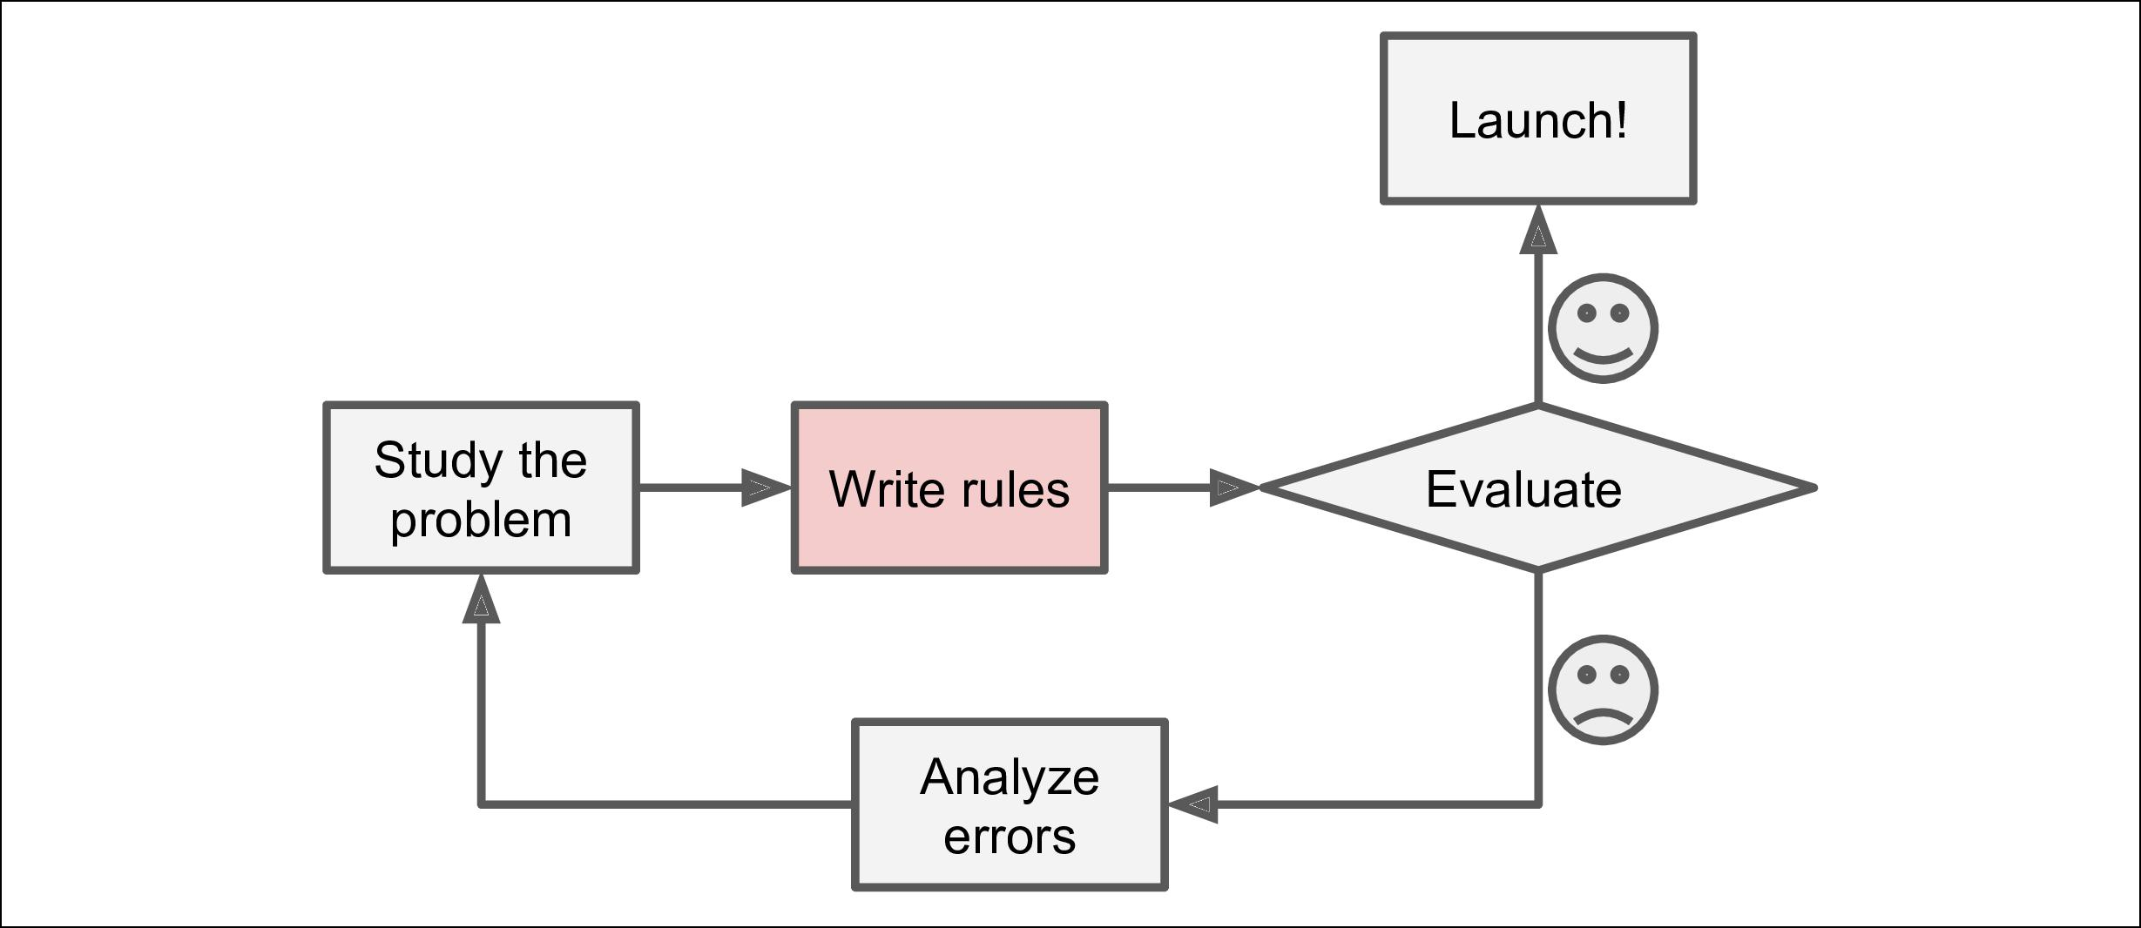

*Figure 1-1. The traditional approach/Cách tiếp cận truyền thống*

Since the problem is not trivial, your program will likely become a long list of com‐ plex rules—pretty hard to maintain.

Vấn đề không phải là nhỏ, chương trình của bạn sẽ trở thành một danh sách dài các quy tắc-rất khó để có thể duy trì.

In contrast, a spam filter based on Machine Learning techniques automatically learns which words and phrases are good predictors of spam by detecting unusually fre‐ quent patterns of words in the spam examples compared to the ham examples (Figure 1-2). The program is much shorter, easier to maintain, and most likely more accurate.

Trái lại, bộ lọc spam trong công nghệ học máy sẽ tự động học những từ và cụm từ được cho là dự đoán tốt về spam bằng cách phát hiện các từ khác thường trong các mẫu về thư rác so với các mẫu thông thường. Lập trình ngắn gọn, dễ duy trì, và có độ chính xác cao.



**Why Use Machine Learning?** **|** **5**

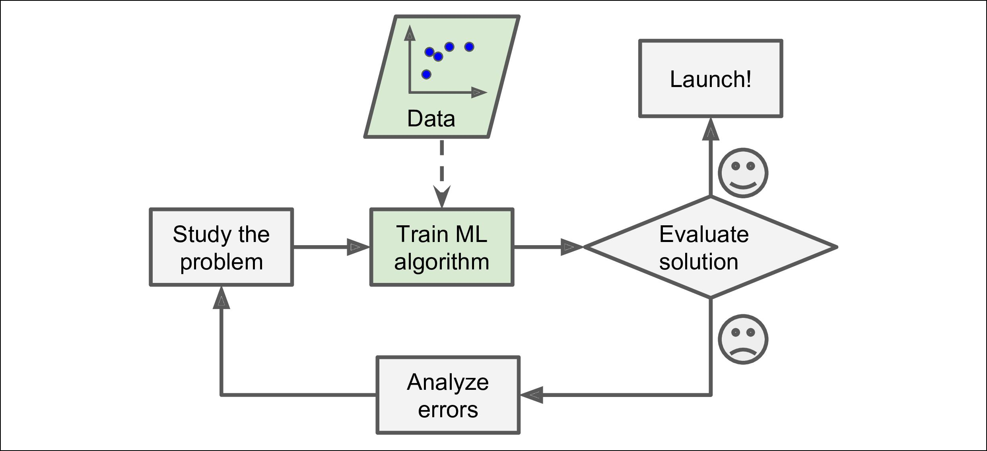

*Figure 1-2. Machine Learning approach*

Moreover, if spammers notice that all their emails containing “4U” are blocked, they might start writing “For U” instead. A spam filter using traditional programming techniques would need to be updated to flag “For U” emails. If spammers keep work‐ ing around your spam filter, you will need to keep writing new rules forever.

Hơn nữa, nếu người spam thấy trong các mail của họ có chứa “4U” sẽ bị khóa, họ có thể bắt đầu viết “là U” để thay thế. Một bộ lọc spam sử dụng công nghệ lập trình truyền thống sẽ cần được cập nhật cờ “là U” trong các mail. Nếu những người spam tiếp tục spam mail của bạn, bạn sẽ cần viết các quy tắc mới cho các từ spam khác.

In contrast, a spam filter based on Machine Learning techniques automatically noti‐ ces that “For U” has become unusually frequent in spam flagged by users, and it starts flagging them without your intervention (Figure 1-3).

Khác với kỹ thuật lập trình truyền thống, một bộ lọc dựa trên các kỹ thuật học máy sẽ tự động thông báo rằng “là U” đã trở nên thường xuyên với người dùng, và tự no sẽ gán cờ spam mà không cần sự can thiệp của bạn.

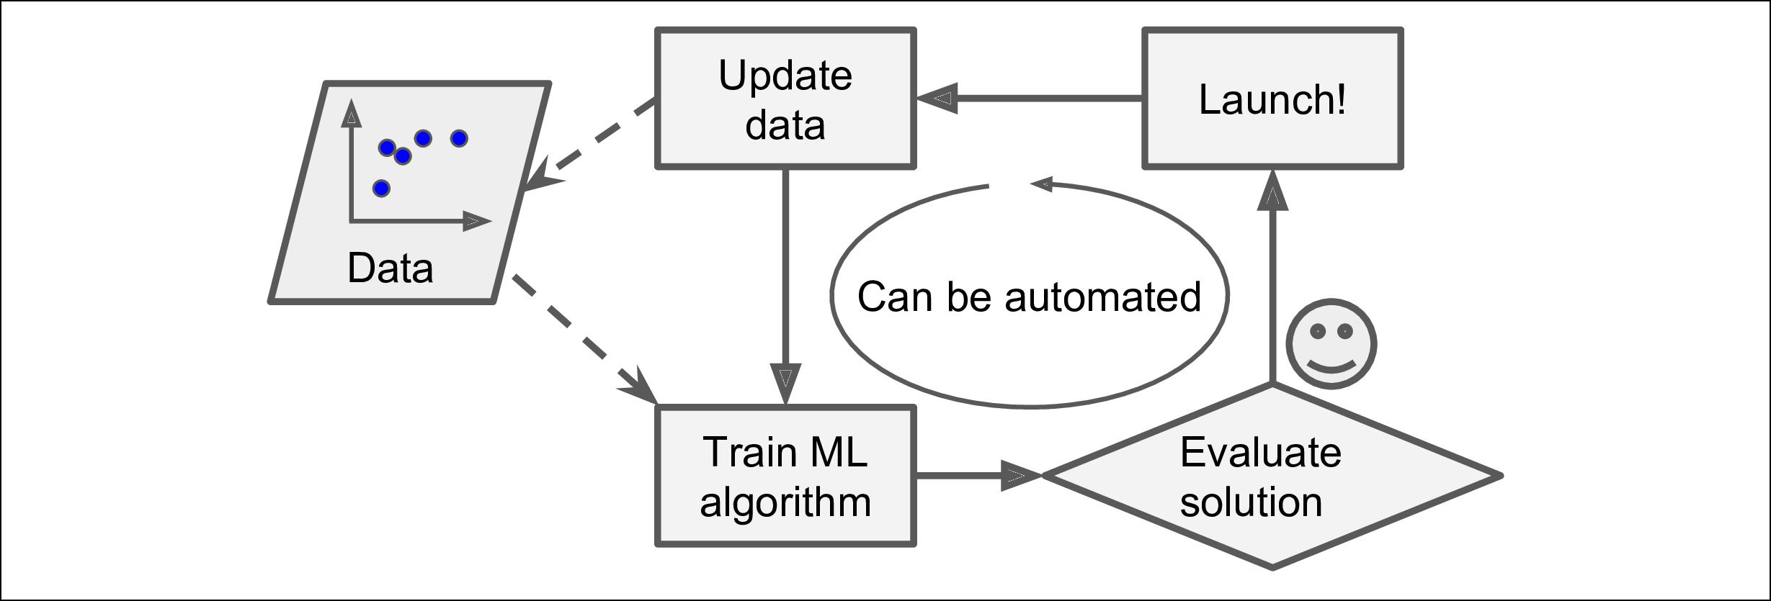

*Figure 1-3. Automatically adapting to change/ Tự động thích nghi để thay đổi*

Another area where Machine Learning shines is for problems that either are too com‐ plex for traditional approaches or have no known algorithm. For example, consider speech recognition: say you want to start simple and write a program capable of dis‐ tinguishing the words “one” and “two.” You might notice that the word “two” starts with a high-pitch sound (“T”), so you could hardcode an algorithm that measures high-pitch sound intensity and use that to distinguish ones and twos. Obviously this technique will not scale to thousands of words spoken by millions of very different



**6** **|** **Chapter 1: The Machine Learning Landscape**

people in noisy environments and in dozens of languages. The best solution (at least today) is to write an algorithm that learns by itself, given many example recordings for each word.

Một lĩnh vực khác mà học máy tỏa sáng là vấn đề nó giải quyết được các vấn đề quá phức tạp trong phương pháp truyền thống hoặc chưa có thuật toán giài quyết. Ví dụ, hãy xem xét về nhận dạng giọng nói: bạn nói muốn bắt đầu đơn giản và viết ra một chương trình có khả năng phân piệt hai từ “one” và “two”. Bạn có thể nhận thấy rằng từ “two” bắt đầu bằng một âm cao “T”, vậy bạn có thể tạo ra một thuật toán để đo lường cường độ âm và sử dụng để phân biệt từ “one” và “two”. Rõ ràng kỹ thuật này sẽ không thể mở rộng đến hàng ngàn từ được nói bởi hàng triệu người khác nhau trong môi trường ồn ào và hàng đống các ngôn ngữ. Giải phát tốt nhất (tới thời điểm hiện tại) là viết ra thuật toán để học bởi chính nó, đưa ra nhiều bản thu cho mỗi từ.

Finally, Machine Learning can help humans learn (Figure 1-4): ML algorithms can be inspected to see what they have learned (although for some algorithms this can be tricky). For instance, once the spam filter has been trained on enough spam, it can easily be inspected to reveal the list of words and combinations of words that it believes are the best predictors of spam. Sometimes this will reveal unsuspected cor‐ relations or new trends, and thereby lead to a better understanding of the problem.

Cuối cùng, học máy có thể giúp con người học: thuật toán học máy có thể kiểm tra xem những gì đã học(tuy rằng đối với một số thuật toán điều này khá khó khăn). Chẳng hạn, một bộ lọc spam đã được huấn luyện với đủ các loại spam, nó có thể dễ dàng phát hiện ra các danh sách từ và các từ kết hợp để nó tin rằng có thể đưa ra dự đoán tốt nhất về các spam. Đôi khi nó phát hiện ra các mối liên hệ và các xu hướng spam mới dẫn đến sự hiểu vấn đề một cách tốt hơn.

Applying ML techniques to dig into large amounts of data can help discover patterns that were not immediately apparent. This is called *data mining*.

Áp dụng các kỹ thuật học máy để đào sâu một lượng dữ liệu lớn có thể giúp khám phá các mẫu không rõ ràng ngay lập tức. Nó được gọi là data mining(khai thác dữ liệu).

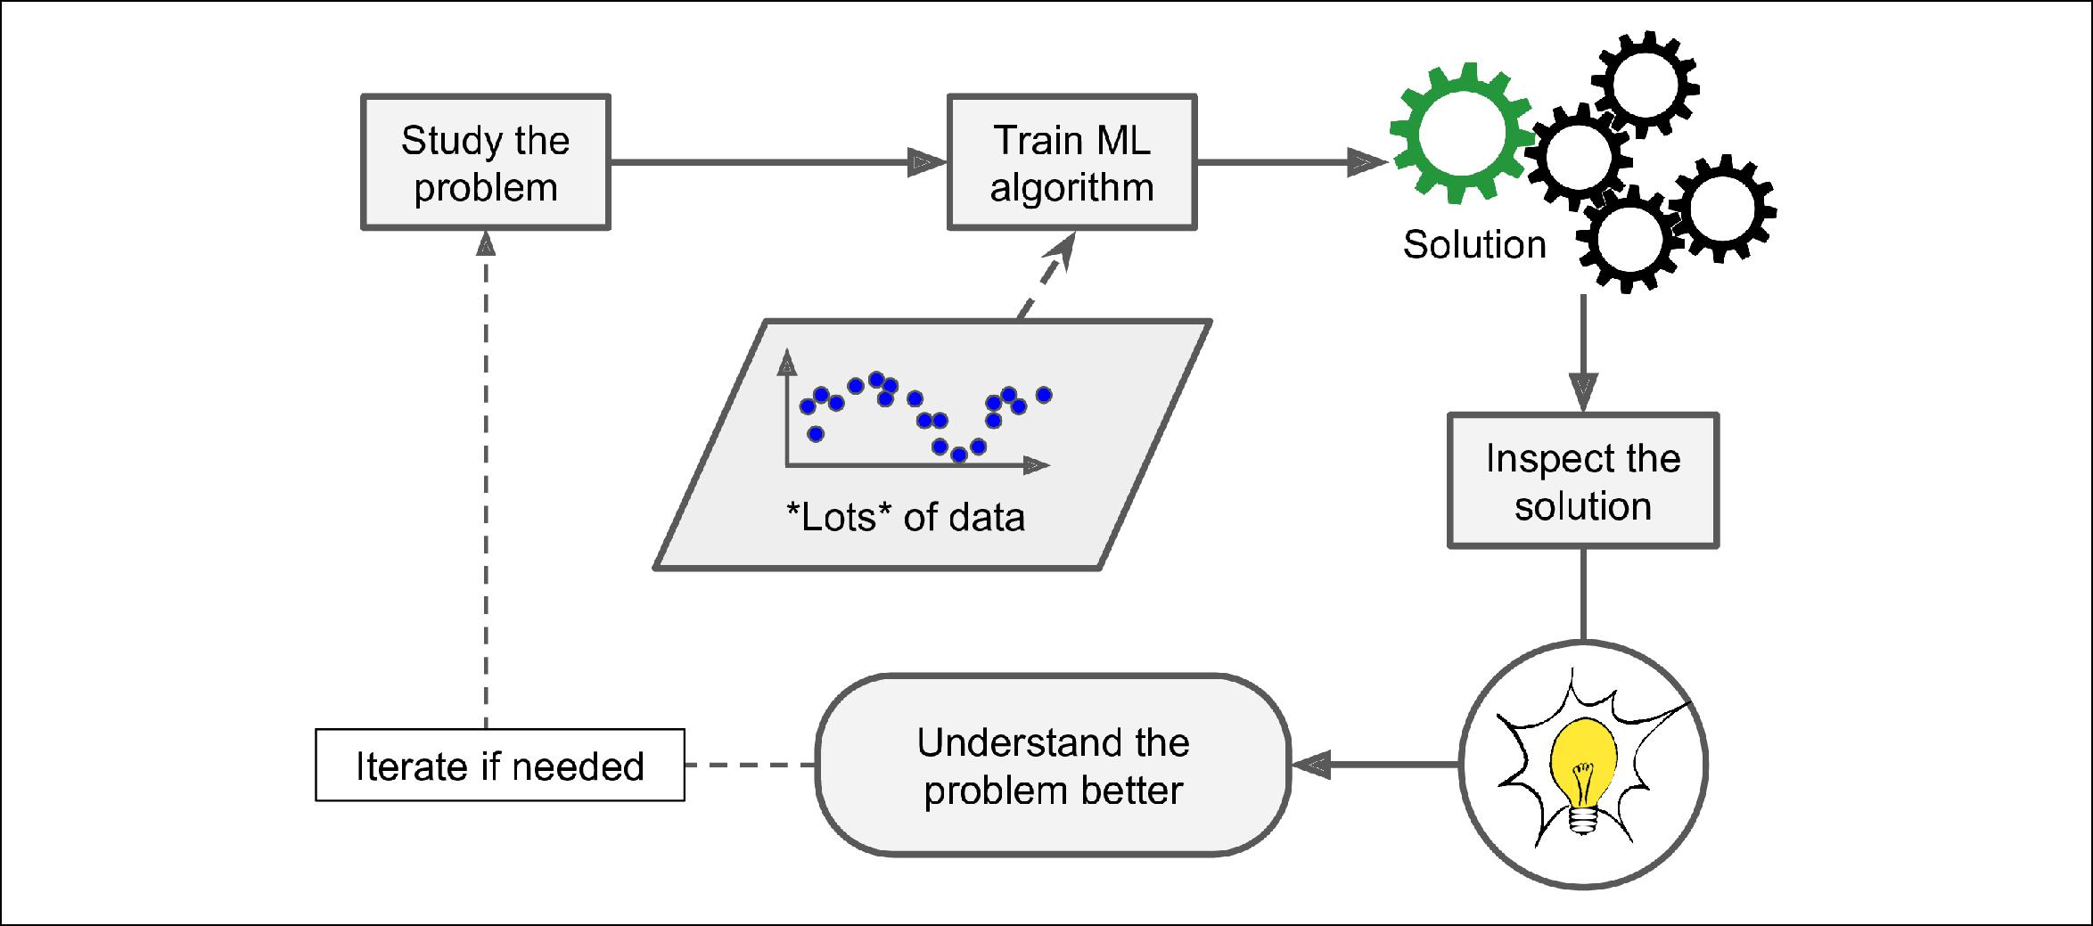

*Figure 1-4. Machine Learning can help humans learn / ML có thể giúp con người học*

To summarize, Machine Learning is great for:

Tổng quan lại, ML là tuyệt vời cho:

* Problems for which existing solutions require a lot of hand-tuning or long lists of rules: one Machine Learning algorithm can often simplify code and perform bet‐ ter.

Giải pháp cho vấn đề đang tồn tại như nhu cầu điều chỉnh nhiều “bằng cơm” hoặc danh sách quy tắc quá dài: một thuật toán học máy có thể đơn giản hóa và thực thi tốt hơn.

* Complex problems for which there is no good solution at all using a traditional approach: the best Machine Learning techniques can find a solution.

Các vấn đề phức tạp mà các phương pháp truyền thống không xử lý tốt được thì các kỹ thuật ML tốt có thể tìm ra giải pháp.

* Fluctuating environments: a Machine Learning system can adapt to new data.

Thích nghi môi trường: một hệ thống ML có thể thích nghi với những dữ liệu mới.

* Getting insights about complex problems and large amounts of data.

Nhận biết được sâu các vấn đề và lượng dữ liệu lớn.



**Why Use Machine Learning?** **|** **7**

**Types of Machine Learning Systems**

**Các kiểu hệ thống ML**

There are so many different types of Machine Learning systems that it is useful to classify them in broad categories based on:

Có rất nhiều loại hệ thống ML rất hữu ích, có thể phân loại chúng dựa trên:

* Whether or not they are trained with human supervision (supervised, unsuper‐ vised, semisupervised, and Reinforcement Learning)

Chúng có thể được huấn luyện có hoặc không có sự giám sát của con người(giám sát, không giám sát, bán giám sát, học củng cố)

* Whether or not they can learn incrementally on the fly (online versus batch learning)

Chúng có thể học từng bước hoặc đồng thời(liên tục hoặc từng phần)

* Whether they work by simply comparing new data points to known data points, or instead detect patterns in the training data and build a predictive model, much like scientists do (instance-based versus model-based learning)

Nó có thể làm việc dựa trên các điểm dữ liệu mới so sánh với các điểm dữ liệu đã biết, hoặc thay vào đó phát hiện các mẫu trong dữ liệu đào tạo và xây dựng mô hình dự đoán, giống như các nhà khoa học đã thực hiện(học dựa vào việc so sánh mô hình với mô hình)

These criteria are not exclusive; you can combine them in any way you like. For example, a state-of-the-art spam filter may learn on the fly using a deep neural net‐ work model trained using examples of spam and ham; this makes it an online, model-based, supervised learning system.

Không nhất thiết phải tuân theo các tiêu chí trên, bạn có thể kết hợp chúng bằng bất kỳ cách nào bạn thích. Ví dụ, một bộ lọc spam hiện đại có thể sử dụng một mô hình mạng học sâu để huấn luyện sử dụng các ví dụ của mail spam và mail bình thường. Nó hoạt động liên tục dựa trên mô hình hệ thống học có giám sát.

Let’s look at each of these criteria a bit more closely.

Hãy cùng xem xét từng tiêu chí này.

**Supervised/Unsupervised Learning**

**Học có giám sát và học không giám sát**

Machine Learning systems can be classified according to the amount and type of supervision they get during training. There are four major categories: supervised learning, unsupervised learning, semisupervised learning, and Reinforcement Learn‐ ing.

Hệ thống ML có thể phân loại theo số lượng hoặc loại giám sát họ dùng trong quá trình đào tạo, Chúng được chia ra thành 4 danh mục chính: học có giám sát, học không giám sát, học bán giám sát, và học củng cố.

**Supervised learning**

**Học có giám sát**

In *supervised learning*, the training data you feed to the algorithm includes the desired solutions, called *labels* (Figure 1-5).

Trong học có giám sát, dữ liệu đào tạo bạn cung cấp cho thuật toán bao gồm các giái pháp lý tưởng, gọi là nhãn.

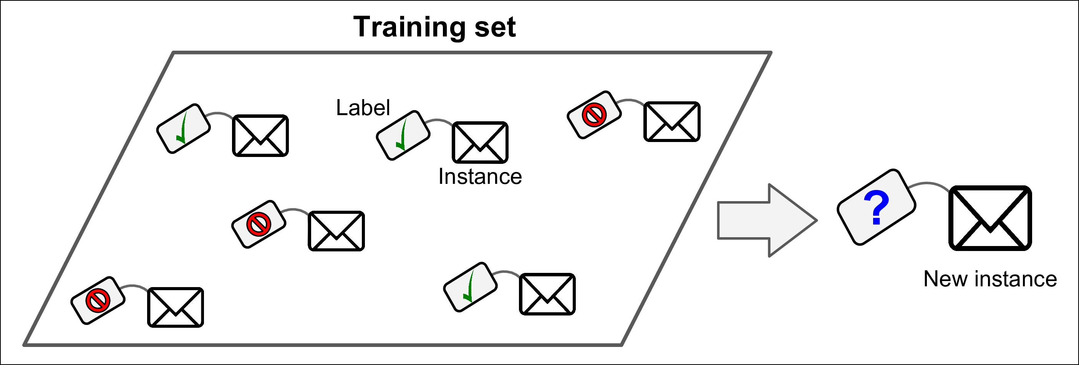

*Figure 1-5. A labeled training set for supervised learning (e.g., spam classification)/Nhãn dữ liệu đã được gán trong học có giám sát*



**8** **|** **Chapter 1: The Machine Learning Landscape**

A typical supervised learning task is *classification*. The spam filter is a good example of this: it is trained with many example emails along with their *class* (spam or ham), and it must learn how to classify new emails.

Một nhiệm vụ điển hình trong học có giám sát là phân loại. Lọc spam là một ví dụ điển hình của nó: nó đã được huấn luyện với nhiều email mẫu cùng với lớp của nó(spam hay k spam), và nó phải học được làm thế nào để phân loại một email mới.

Another typical task is to predict a *target* numeric value, such as the price of a car, given a set of *features* (mileage, age, brand, etc.) called *predictors*. This sort of task is called *regression* (Figure 1-6 ).1 To train the system, you need to give it many examples of cars, including both their predictors and their labels (i.e., their prices).

Một nhiệm vụ điển hình khác là dự đoán giá trị của mục tiêu, như là giá xe hơi, dựa trên những đặc trưng đã được gán (số dặm đã đi, số tuổi đời, thương hiệu, vv…) gọi là dự đoán. Loại này được gọi là hồi quy. Để huấn luyện hệ thống, bạn cần nhiều ví dụ về các loại xe, bao gầm cả hai là dự đoán và nhãn của chúng.

In Machine Learning an *attribute* is a data type (e.g., “Mileage”), while a *feature* has several meanings depending on the context, but generally means an attribute plus its value (e.g., “Mileage = 15,000”). Many people use the words *attribute* and *feature* inter‐ changeably, though.

Trong ML thuộc tính là một kiểu dữ liệu(ví dụ như là số dặm đã đi) trong khi một đặc trưng phụ thuộc vào ngữ cảnh, nhưng thường là một thuộc tính cộng với giá trị của chúng(ví dụ như số dặm đã đi là 15,000). Mặc dù, rất nhiều người sử dụng các từ thuộc tính và các đặc trưng thay thế.

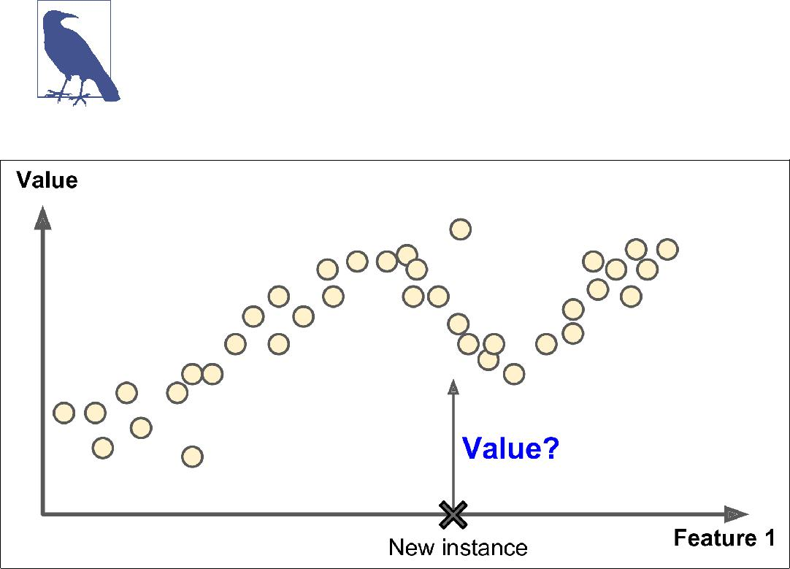

*Figure 1-6. Regression/Hồi quy*

Note that some regression algorithms can be used for classification as well, and vice versa. For example, *Logistic Regression* is commonly used for classification, as it can output a value that corresponds to the probability of belonging to a given class (e.g., 20% chance of being spam).

Lưu ý rằng một vài thuật toán hồi quy có thể sử dụng phân loại rất tốt và ngược lại. Ví dụ, Hồi quy tuyến tính thông thường là sử dụng cho cái bài toán phân loại, như nó có thể có giá trị đầu ra tương ứng với xác suất của một lớp nhất định(ví dụ 20% là thư rác)



1. Fun fact: this odd-sounding name is a statistics term introduced by Francis Galton while he was studying the fact that the children of tall people tend to be shorter than their parents. Since children were shorter, he called this *regression to the mean*. This name was then applied to the methods he used to analyze correlations between variables.



**Types of Machine Learning Systems** **|** **9**

Here are some of the most important supervised learning algorithms (covered in this book):

Dưới đây là một vài thuật toán học có giám sát quan trọng(trong cuốn sách này)

* k-Nearest Neighbors
* Linear Regression
* Logistic Regression
* Support Vector Machines (SVMs)
* Decision Trees and Random Forests
* Neural networks2

**Unsupervised learning**

**Học không giám sát**

In *unsupervised learning*, as you might guess, the training data is unlabeled (Figure 1-7). The system tries to learn without a teacher.

Trong học không giám sát, được hiểu như bạn đoán, dữ liệu huấn luyện không được gán nhãn. Hệ thống sẽ cố gắng học mà không có người dạy.

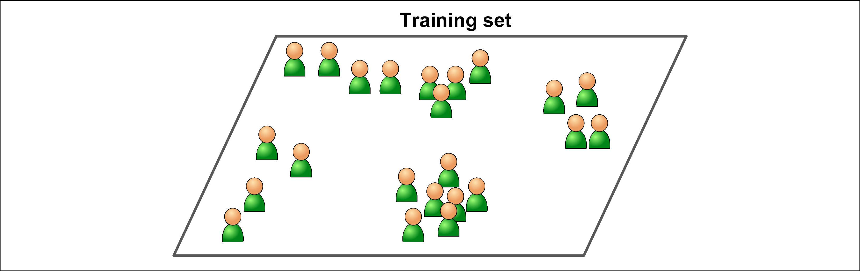

*Figure 1-7. An unlabeled training set for unsupervised learning/ Dữ liệu không được gán nhãn trong học không giám sát*

Here are some of the most important unsupervised learning algorithms (most of these are covered in Chapter 8 and Chapter 9):

Dưới đây là một số thuật toán học không giám sát quan trọng(nó sẽ được đề cập thêm ở Chapter 8 và 9)

* Clustering/Phân cụm

— K-Means

— DBSCAN

— Hierarchical Cluster Analysis (HCA)

* Anomaly detection and novelty detection/Phát hiện bất thường và phát hiện mới

— One-class SVM

— Isolation Forest



1. Some neural network architectures can be unsupervised, such as autoencoders and restricted Boltzmann machines. They can also be semisupervised, such as in deep belief networks and unsupervised pretraining.



**10** **|** **Chapter 1: The Machine Learning Landscape**

* Visualization and dimensionality reduction/ Trực quan hóa và giảm số chiều

— Principal Component Analysis (PCA)

— Kernel PCA

— Locally-Linear Embedding (LLE)

— t-distributed Stochastic Neighbor Embedding (t-SNE)

* Association rule learning/ Học khai phá

— Apriori

— Eclat

For example, say you have a lot of data about your blog’s visitors. You may want to run a *clustering* algorithm to try to detect groups of similar visitors (Figure 1-8). At no point do you tell the algorithm which group a visitor belongs to: it finds those connections without your help. For example, it might notice that 40% of your visitors are males who love comic books and generally read your blog in the evening, while 20% are young sci-fi lovers who visit during the weekends, and so on. If you use a *hierarchical clustering* algorithm, it may also subdivide each group into smallergroups. This may help you target your posts for each group.

Ví dụ, bạn có rất nhiều dữ liệu trong những người ghé thăm blog của bạn. Bạn có muốn chạy một thuật toán phân cụm cố gắng phát hiện ra nhóm những người giống nhau. Không có điểm nào để nói thuật toán mà khách truy cập thuộc nhóm nào: nó sẽ tìm sự kết nối đó mà không cần sự giúp đỡ từ bạn. Ví dụ, nó có thể phát hiện 40% khách thăm quan là nam và thích truyện tranh và thường xuyên đọc blog của bạn vào buổi tốt, trong khi 20% là người yêu thích khoa học viễn tưởng sẽ ghé thăm vào cuối tuần. Nếu bạn sử dụng một thuật toán phân cụm theo tầng, nó có thể chia nhỏ từng nhóm thành những nhóm nhỏ hơn. Nó có thể giúp bạn đăng bài theo đối tượng nào trong từng nhóm.

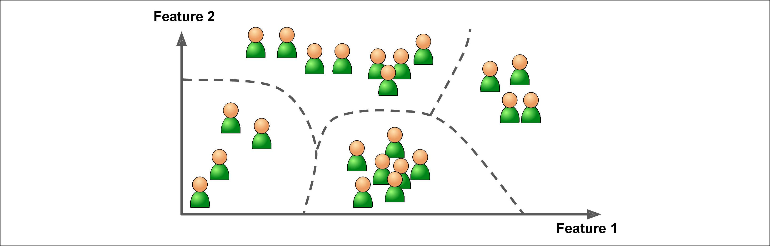

*Figure 1-8. Clustering/Phân cụm*

*Visualization* algorithms are also good examples of unsupervised learning algorithms:you feed them a lot of complex and unlabeled data, and they output a 2D or 3D rep‐ resentation of your data that can easily be plotted (Figure 1-9). These algorithms try to preserve as much structure as they can (e.g., trying to keep separate clusters in the input space from overlapping in the visualization), so you can understand how the data is organized and perhaps identify unsuspected patterns.

Thuật toán trực quan hóa cũng là một ví dụ tốt của thuật toán học không giám sát:bạn cung cấp cho nó rất nhiều dữ liệu phức tạp và không được gán nhãn, và đầu ra là dữ liệu 2 chiều hoặc 3 chiều đại diện cho dữ liệu của bạn có thể dễ dàng được tái hiện quan sát. Các thuật toán này sẽ cố gắng đề không làm thay đổi cấu trúc của bạn hết mức có thể(ví dụ cố gắng phân thành các cụm riêng biệt các không gian đầu vào khỏi sự chồng chéo khi biểu diễn trực quan), vậy bạn có thể hiểu làm thế nào để tổ chức dữ liệu và có thể định nghĩa các mẫu mà không làm ảnh hưởng.



**Types of Machine Learning Systems** **|** **11**

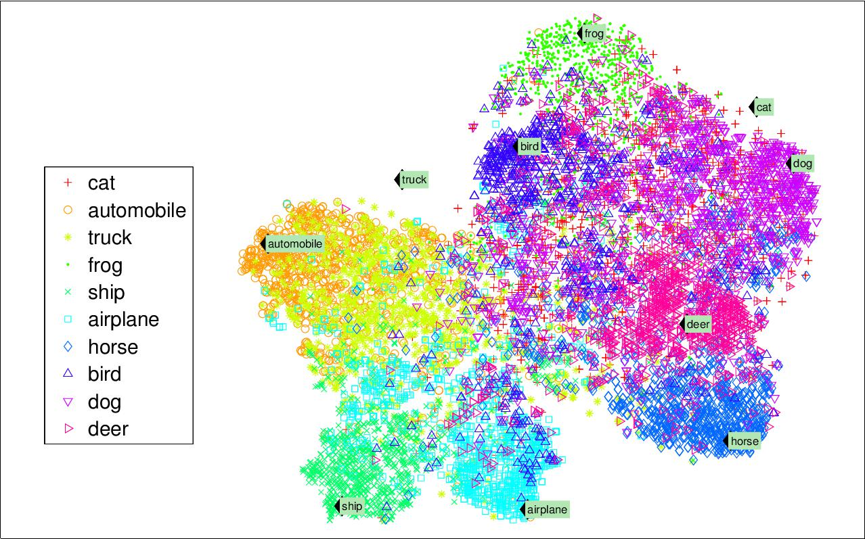

*Figure 1-9. Example of a t-SNE visualization highlighting semantic clusters**3*

A related task is *dimensionality reduction*, in which the goal is to simplify the data without losing too much information. One way to do this is to merge several correla‐ ted features into one. For example, a car’s mileage may be very correlated with its age, so the dimensionality reduction algorithm will merge them into one feature that rep‐ resents the car’s wear and tear. This is called *feature extraction*.

Một sự liên quan đến giảm số chiều, trong đó việc đơn giản hóa dữ liệu mà không làm mất quá nhiều thông tin. Một cách là nhập một tính năng thành một. Ví dụ, số dặm đi được của một chiếc xe oto có thể tương quan với tuổi đời của nó, vậy thuật toán giảm số chiều sẽ nhập chúng thành một đặc trưng đại diện cho sự hao mòn của chiếc xe. Nó gọi là trích xuất đặc trưng.



It is often a good idea to try to reduce the dimension of your train‐ ing data using a dimensionality reduction algorithm before you feed it to another Machine Learning algorithm (such as a super‐ vised learning algorithm). It will run much faster, the data will take up less disk and memory space, and in some cases it may also per‐ form better.

Nó thường sẽ là một ý tưởng tốt để giảm số chiều trong dữ liệu huấn luyện sử dụng thuật toán giảm số chiều trước khi bạn cho vào một thuật toán học máy khác(như là thuật toán học có giám sát). Nó sẽ chạy nhanh hơn, dữ liệu sẽ chiếm ít dung lượng đĩa hơn và bộ nhớ sẽ trống hơn và trong vài trường hợp nó sẽ hoạt động tốt hơn.

Yet another important unsupervised task is *anomaly detection*—for example, detect‐ ing unusual credit card transactions to prevent fraud, catching manufacturing defects, or automatically removing outliers from a dataset before feeding it to another learn‐ ing algorithm. The system is shown mostly normal instances during training, so it learns to recognize them and when it sees a new instance it can tell whether it looks like a normal one or whether it is likely an anomaly (see Figure 1-10). A very similar task is *novelty detection*: the difference is that novelty detection algorithms expect to see only normal data during training, while anomaly detection algorithms are usually more tolerant, they can often perform well even with a small percentage of outliers in the training set.

Một trong nhiệm vụ quan trong khác của học không giám sát là phát hiện bất thường- ví dụ, lịch sử giao dịch thẻ tín dụng bất thường để ngăn chặn hành vi, phát hiện lỗi trong sản xuất, hoặc tự động loại bỏ các ngoại lệ từ bộ dữ liệu trước khi đưa nó vào một thuật toán khác. Hệ thống sẽ cho thấy hầu hết các trường bình thường trong quá trình đào tạo, vậy nó sẽ học để nhận ra chúng và khi nào nó thấy một đối tượng mới có thể nói rằng nó bình thường hay bất thường. Một nhiệm vụ khá tương đồng với việc phát hiện bất thường là phát hiện cái mới: sự khác biệt là thuật toán phát hiện cái mới chỉ chỉ nhìn thấy mỗi dữ liệu bình thường trong quá trình huấn luyện, trong khi thuật toán phát hiện sự bất thường sẽ có khả năng ứng phó tốt hơn vì chúng thực hiện tốt ngay cả khi có các tỷ lệ nhỏ các ngoại lệ trong tập dữ liệu.



1. Notice how animals are rather well separated from vehicles, how horses are close to deer but far from birds, and so on. Figure reproduced with permission from Socher, Ganjoo, Manning, and Ng (2013), “T-SNE visual‐ ization of the semantic word space.”



**12** **|** **Chapter 1: The Machine Learning Landscape**

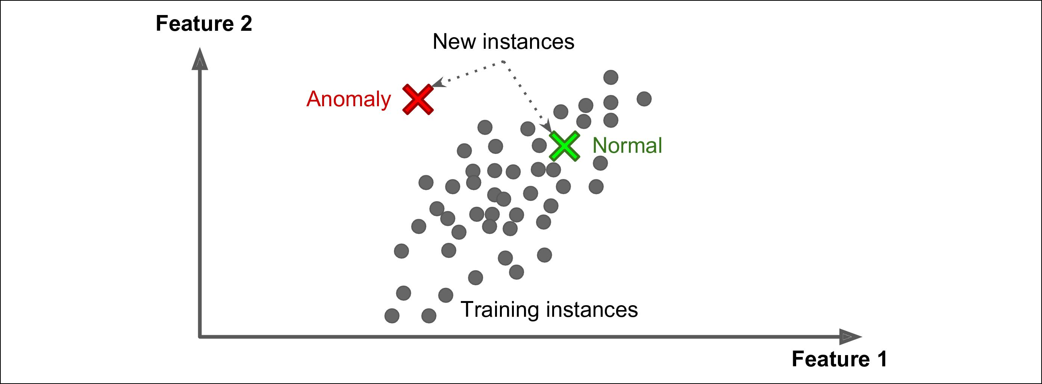

*Figure 1-10. Anomaly detection/ phát hiện bất thường*

Finally, another common unsupervised task is *association rule learning*, in which the goal is to dig into large amounts of data and discover interesting relations between attributes. For example, suppose you own a supermarket. Running an association rule on your sales logs may reveal that people who purchase barbecue sauce and potato chips also tend to buy steak. Thus, you may want to place these items close to each other.

Cuối cùng, một nhiệm vụ khác trong học không giám sát là học khai phá, trong đó mục tiêu là đào sâu vào một lượng dữ liệu lớn và khám phá các mối quan hệ thú vị giữa các thuộc tính. Ví dụ, giả sử bạn sở hữu cả một siêu thị. Chạy ra khám phá sổ nhật ký bán hàng có thể tiết lộ những người mua sốt thịt nướng khoai tây chiên và cũng có xu hướng mua bít tết. Vì vậy, bạn có thể muốn đặt các thứ đó gần nhau hơn.

**Semisupervised learning/Học bán giám sát**

Some algorithms can deal with partially labeled training data, usually a lot of unla‐ beled data and a little bit of labeled data. This is called *semisupervised learning* (Figure 1-11).

Một số thuật toán xử lý dữ liệu huấn luyện được gán nhãn một phần, thường có rất nhiều dữ liệu không gán nhãn và một ít dữ liệu được gán nhãn. Nó được gọi là học bán giám sát.

Some photo-hosting services, such as Google Photos, are good examples of this. Once you upload all your family photos to the service, it automatically recognizes that the same person A shows up in photos 1, 5, and 11, while another person B shows up in photos 2, 5, and 7. This is the unsupervised part of the algorithm (clustering). Now all the system needs is for you to tell it who these people are. Just one label per person,4 and it is able to name everyone in every photo, which is useful for searching photos.

Một vài dịch vụ lưu trữ hình ảnh, như là GG Photos là một ví dụ điển hình. Trong khi bạn đẩy nhiều ảnh gia đình của bạn lên dịch vụ, nó sẽ tự động nhận ra là khoảng bảo nhiêu được hiện lên ở ảnh 1,5,11 trong khi một người B khác hiện lên ở ảnh 2,5,7. Đó là một phần của học không được giám sát(Phân cụm). Bây giờ tất cả các hệ thống cần là nói cho bạn biết nhũng người đó là ai. Chỉ một số người được bán nhãn, and nó có thể có tên mỗi người trên mỗi ảnh, nó thật sự hữu ích cho việc tìm kiếm ảnh.



1. That’s when the system works perfectly. In practice it often creates a few clusters per person, and sometimes mixes up two people who look alike, so you need to provide a few labels per person and manually clean up some clusters.



**Types of Machine Learning Systems** **|** **13**

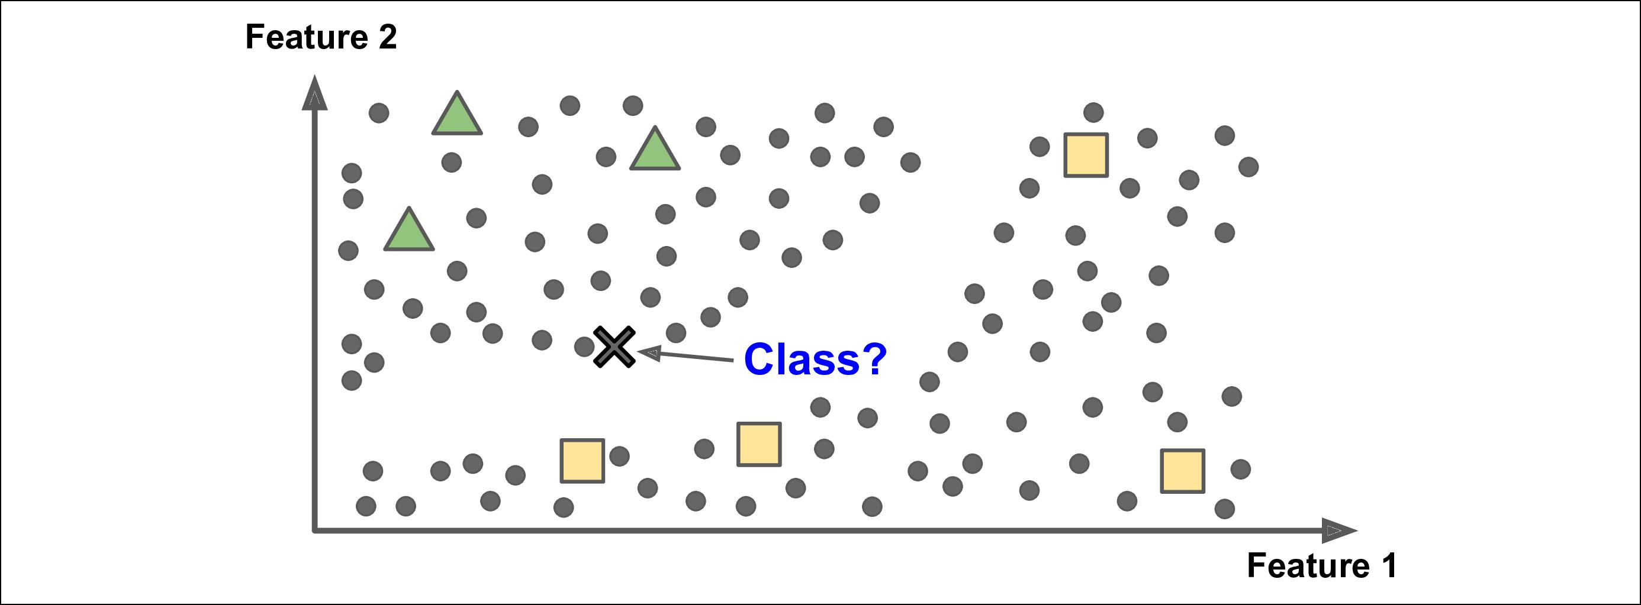

*Figure 1-11. Semisupervised learning/ Học bán giám sát*

Most semisupervised learning algorithms are combinations of unsupervised and supervised algorithms. For example, *deep belief networks* (DBNs) are based on unsu‐ pervised components called *restricted Boltzmann machines* (RBMs) stacked on top of one another. RBMs are trained sequentially in an unsupervised manner, and then the whole system is fine-tuned using supervised learning techniques.

Nhiều thuật toán học bán giám sát là kết hợp của học không giám sát và học có giám sát. Ví dụ, *deep belief networks* (DBNs) là dựa trên các thành phần của không giám sát được gọi là *restricted Boltzmann machines* (RBMs) xếp chồng lên nhau. RBMs được đào tạo tuần tự theo cách học không giám sát, và sau đó toàn bộ hệ thống sẽ được tinh chỉnh bằng cách sử dụng các kỹ thuật học có giám sát.

**Reinforcement Learning**

**Học củng cố**

*Reinforcement Learning* is a very different beast. The learning system, called an *agent* in this context, can observe the environment, select and perform actions, and get *rewards* in return (or *penalties* in the form of negative rewards, as inFigure 1-12). Itmust then learn by itself what is the best strategy, called a *policy*, to get the most reward over time. A policy defines what action the agent should choose when it is in a given situation.

Học củng cố là phần khó nhất. Hệ thống sẽ tự học từ tác động của ngữ cảnh, có thể quan sát môi trường, chọn ra và thực hiện hành động và nhận lại được một phần thưởng(hoặc trừng phạt dưới dạng phần thưởng tiêu cực). Nó phải tự học theo cách tốt nhất gọi là chính sách, để nhận được nhiều phần thường nhất theo thời gian. Trong chính sách định nghĩa nên làm gì trong một tình huống nhất định.



**14** **|** **Chapter 1: The Machine Learning Landscape**

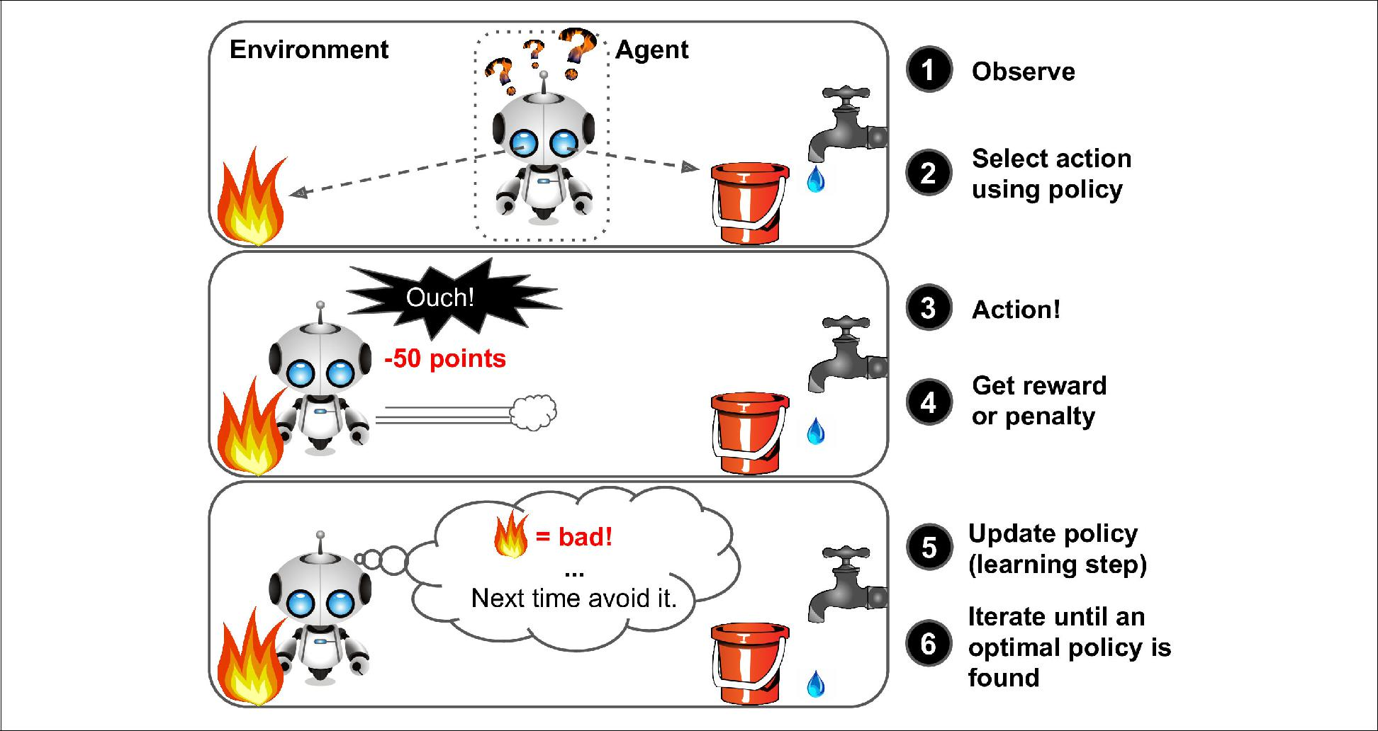

*Figure 1-12. Reinforcement Learning/ Học củng cố*

For example, many robots implement Reinforcement Learning algorithms to learn how to walk. DeepMind’s AlphaGo program is also a good example of Reinforcement Learning: it made the headlines in May 2017 when it beat the world champion Ke Jie at the game of *Go*. It learned its winning policy by analyzing millions of games, and then playing many games against itself. Note that learning was turned off during the games against the champion; AlphaGo was just applying the policy it had learned.

Ví dụ, nhiều rô bốt hoạt động trên thuật toán học củng có để học thế nào có thể đi. Chương trình DeepMind’s AlphaGo là một trong số những ví dụ tốt của học củng cố: nó được làm ra từ đàu tháng năm năm 2017 khi nó đánh bại nhà vô đich Ke Jie ở trò chơi cờ vây. Nó đã học những chính sách chiến thắng bằng cách phân tích hàng triệu nước đi của trò chơi, và sau đó nó chơi lại với chính nó. Lưu ý rằng việc học của nó đã được tắt khi chơi vs nhà vô địch, AlphaGo chỉ đang dùng cái nó học được.

**Batch and Online Learning/ Học từng phần và học liên tục**

Another criterion used to classify Machine Learning systems is whether or not the system can learn incrementally from a stream of incoming data.

Một tiêu chí khác của việc phân loại hệ thống ML là liệu hệ thống có thể học từ một luồng dữ liệu liên tục không

**Batch learning/ học từng phần**

In *batch learning*, the system is incapable of learning incrementally: it must be trained using all the available data. This will generally take a lot of time and computing resources, so it is typically done offline. First the system is trained, and then it is launched into production and runs without learning anymore; it just applies what it has learned. This is called *offline learning*.

Trong học theo từng phần, hệ thống không có khả năng học liên tục: nó phải được đào tạo bằng việc sử dụng tất cả dữ liệu có sãn. Điều này sẽ gây tốn nhiều thời gian và tài nguyên, vậy nên nó được thực hiện khi có dữ liệu cố định và không thay đổi. Đầu tiên hệ thống sẽ huấn luyện, và sau đó nó sẽ thực hiện mà không cần học nữa, nó chỉ áp dụng những gì nó đã học được. Đây gọi là học ngoại tuyến.

If you want a batch learning system to know about new data (such as a new type of spam), you need to train a new version of the system from scratch on the full dataset (not just the new data, but also the old data), then stop the old system and replace it with the new one.

Nếu bạn muốn hệ thống học theo từng phần biết dữ liệu mới(như là một kiểu spam mới), bạn cần huấn luyện một phiên bản mới cho hệ thống từ đầu trên bộ dữ liệu đầy đủ(không chỉ dữ liệu mới và cả dữ liệu cũ), sau đó dừng hệ thống cũ thay thế bằng dữ liệu mới.

Fortunately, the whole process of training, evaluating, and launching a Machine Learning system can be automated fairly easily (as shown in Figure 1-3), so even a batch learning system can adapt to change. Simply update the data and train a new version of the system from scratch as often as needed.

May mắn thay, toàn bộ quá trình đào tạo, đánh giá, và vận hành của hệ thống học máy có thể tự động hóa dễ dàng, do đó hệ thống học từng phần có thể thích ứng để thay đổi. Đơn giản chỉ việc cập nhật dữ liệu và huấn luyện một phiên bản mới của hệ thống từ ban đầu một cách thường xuyên.



**Types of Machine Learning Systems** **|** **15**

This solution is simple and often works fine, but training using the full set of data can take many hours, so you would typically train a new system only every 24 hours or even just weekly. If your system needs to adapt to rapidly changing data (e.g., to pre‐ dict stock prices), then you need a more reactive solution.

Biện pháp này đơn giản và thường xuyên làm việc tốt, nhưng quá trình huấn luyện sử dụng toàn bộ dữ có thể mất nhiều giờ đồng hồ, vậy nên thậm chí bạn huấn luyện hệ thống mới mỗi 24 giờ hoặc thậm chí mỗi tuần. Nếu hệ thống bạn cần thích ứng nhanh với dữ liệu (như giá trị kho), bạn cần giải pháp tốt hơn.

Also, training on the full set of data requires a lot of computing resources (CPU, memory space, disk space, disk I/O, network I/O, etc.). If you have a lot of data and you automate your system to train from scratch every day, it will end up costing you a lot of money. If the amount of data is huge, it may even be impossible to use a batch learning algorithm.

Ngoài ra, việc huấn luyện toàn bộ dữ liệu đòi hỏi nhiều tài nguyên tính toán(CPU, bộ nhớ, ổ đĩa, đĩa I/O, mạng I/O, vv…). Nếu bạn có nhiều dữ liệu và bạn tự động hóa hệ thống của bạn để huấn luyện mỗi ngày, nó sẽ tốn rất nhiều tiền. Nếu có một lượng dữ liệu khổng lồ, có thể thuật toán học theo từng phần cũng không sử dụng được.

Finally, if your system needs to be able to learn autonomously and it has limited resources (e.g., a smartphone application or a rover on Mars), then carrying around large amounts of training data and taking up a lot of resources to train for hours every day is a showstopper.

Cuối cùng, nếu hệ thống bạn cần có khả năng tự học và có tài nguyên hạn chế(như ứng dụng di dộng), sau đó mang một lượng lớn dữ liệu đi đào tạo và chiếm nhiều tài nguyên trong hàng giờ mỗi ngày để chương trình dừng.

Fortunately, a better option in all these cases is to use algorithms that are capable of learning incrementally.

May mắn thay, có sự lựa chọn tốt hơn trong tất cả các trường hợp này là chúng ta có thể sự dụng thuật toán học liên tục.

**Online learning/Học liên tục**

In *online learning*, you train the system incrementally by feeding it data instances sequentially, either individually or by small groups called *mini-batches*. Each learning step is fast and cheap, so the system can learn about new data on the fly, as it arrives (see Figure 1-13).

Trong học liên tục, bạn huấn luyện hệ thống liên tục bằng cách cung cấp dữ liệu theo từng đợt có tuần tự, theo từng cá thể hoặc một nhóm nhỏ gọi là mini-batches. Mỗi bước học nhanh và tiết kiệm, vậy nên hệ thống có thể học những dữ liệu mới khi đang vận hành.

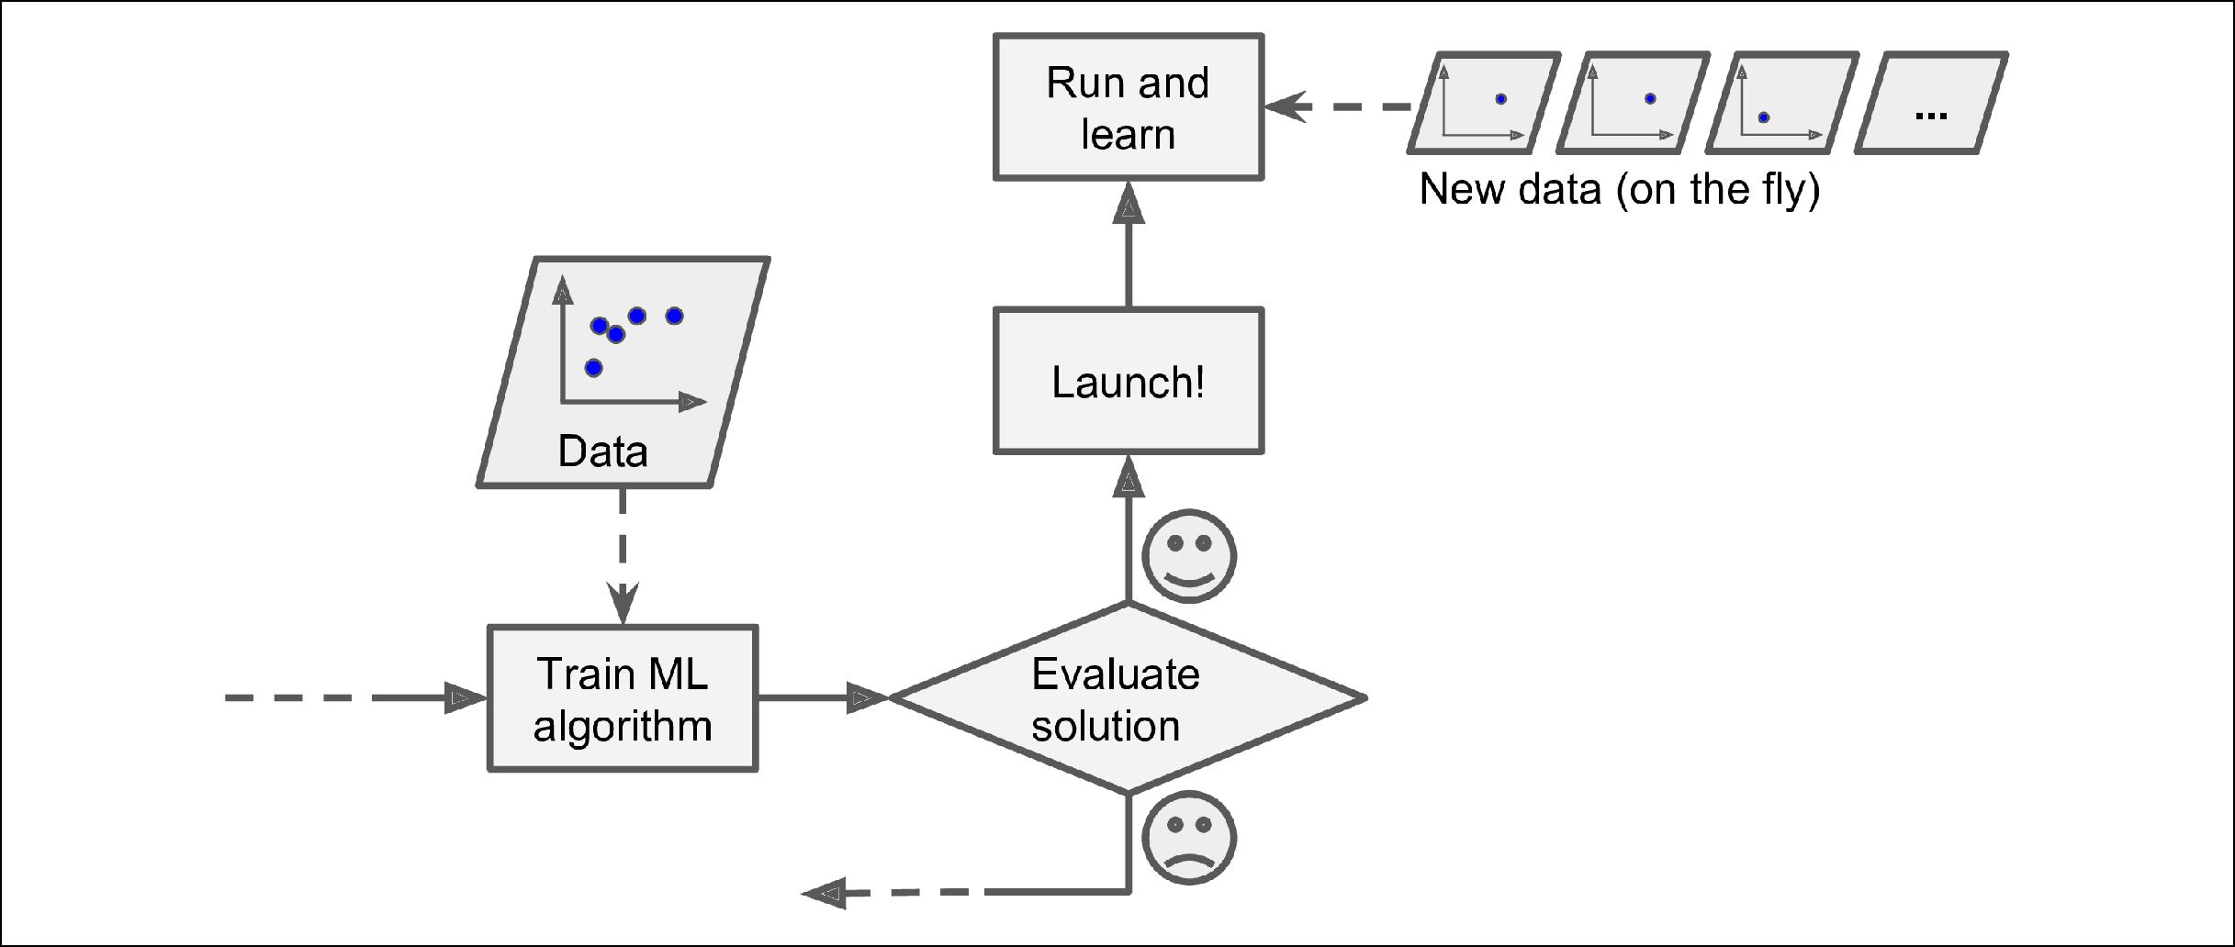

*Figure 1-13. Online learning/ Học liên tục*

Online learning is great for systems that receive data as a continuous flow (e.g., stock prices) and need to adapt to change rapidly or autonomously. It is also a good option if you have limited computing resources: once an online learning system has learned about new data instances, it does not need them anymore, so you can discard them (unless you want to be able to roll back to a previous state and “replay” the data). This can save a huge amount of space.

Học liên tục là sự lựa chọn tuyệt vời cho hệ thống khi nhận luồng dữ liệu liên tục(như giá trị kho) và thích ứng được sự thay đổi nhanh chóng và tự chủ. Nó cũng là sự lưa chọn tốt nếu bạn có tài nguyên hạn chế: trong khi hệ thống học liên tục sẽ có những đối tượng mới, nó không cần chúng, vậy bạn có thể loại bỏ chúng(trừ khi bạn muốn quay lại và thêm dữ liệu rồi chạy lại). Nó có thể tiết kiệm một lượng lớn không gian tài nguyên.



**16** **|** **Chapter 1: The Machine Learning Landscape**

Online learning algorithms can also be used to train systems on huge datasets that cannot fit in one machine’s main memory (this is called *out-of-core* learning). The algorithm loads part of the data, runs a training step on that data, and repeats the process until it has run on all of the data (see Figure 1-14).

Thuật toán học liên tục có thể sử dụng để huấn luyện các hệ thống trên một lượng dữ liệu lớn không thể chứa trên bộ nhớ của một chiếc máy(nó được gọi là học bên ngoài). Thuật toán sẽ chạy qua từng phần của bộ dữ liệu, nó sẽ huấn luyện từng bước trên dữ liệu đó và lặp lại quá trình cho đến khi nó đã chạy qua toàn bộ dữ liệu.

Out-of-core learning is usually done offline (i.e., not on the live system), so *online learning* can be a confusing name. Think of it as *incremental learning*.

Học bên ngoài thường được thực hiện cố định (nghĩa là không phải trực tiếp trên hệ thống), vậy học liên tục có thể là một cái tên khó hiểu. Hãy suy nghĩ như nó học thêm.

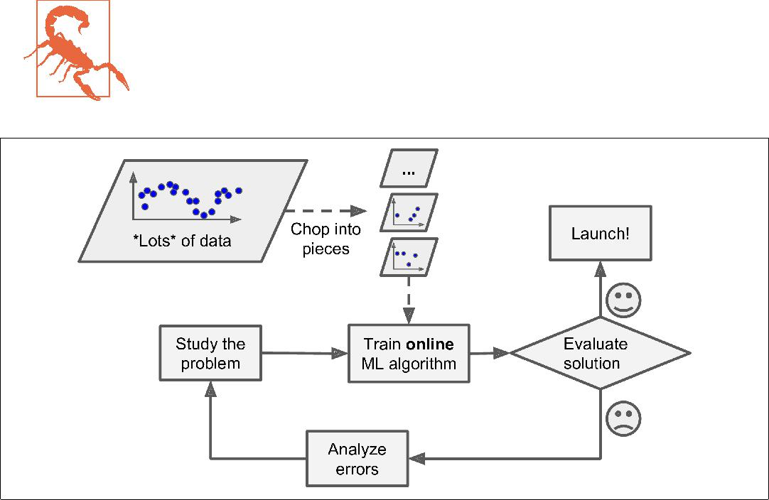

*Figure 1-14. Using online learning to handle huge datasets/ Sử dụng học liên tục để xử lý các dữ liệu lớn*

One important parameter of online learning systems is how fast they should adapt to changing data: this is called the *learning rate*. If you set a high learning rate, then your system will rapidly adapt to new data, but it will also tend to quickly forget the old data (you don’t want a spam filter to flag only the latest kinds of spam it was shown). Conversely, if you set a low learning rate, the system will have more inertia; that is, it will learn more slowly, but it will also be less sensitive to noise in the new data or to sequences of nonrepresentative data points (outliers).

Một tham số quan trọng của hệ thống học liên tục là làm thế nào để thích ứng nhanh với việc thay đổi dữ liệu: nó được gọi là learning rate. Nếu bạn gán một learning rate cao, sau đó hệ thống của bạn sẽ thích ứng rất nhanh với dữ liệu mới, nhưng nó sẽ có xu hướng nhanh quên các dữ liệu cũ(tất nhiên bạn không muốn bộ lọc spam chỉ gán cờ các loại spam mới nhất). Ngược lại, nếu bạn gán một learning rate thấp, hệ thống sẽ có quán tính lớn hơn, nghĩa là nó sẽ học chậm hơn, nhưng nó sẽ bớt nhạy cảm với nhiễu trên dữ liệu mới hoặc không đi qua những điểm dữ liệu được coi là ngoại lệ.

A big challenge with online learning is that if bad data is fed to the system, the sys‐ tem’s performance will gradually decline. If we are talking about a live system, your clients will notice. For example, bad data could come from a malfunctioning sensor on a robot, or from someone spamming a search engine to try to rank high in search results. To reduce this risk, you need to monitor your system closely and promptly switch learning off (and possibly revert to a previously working state) if you detect a drop in performance. You may also want to monitor the input data and react to abnormal data (e.g., using an anomaly detection algorithm).

Một thách thức lớn với việc học liên tục là nếu dữ liệu xấu được cung cấp cho hệ thống, hiệu suất của hệ thống sẽ giảm dần. Nếu chúng ta đang nói về một hệ thống đang vận hành, máy trạm của bạn sẽ nhận ra. Ví dụ: dữ liệu xấu có thể đến từ cảm biến trục trặc trên robot hoặc từ ai đó đang spam công cụ tìm kiếm để cố gắng lên top trong kết quả tìm kiếm. Để giảm thiểu rủi ro này, bạn cần giám sát chặt chẽ hệ thống của mình và nhanh chóng tắt việc học (và có thể trở lại trạng thái hoạt động trước đó) nếu bạn phát hiện sự sụt giảm hiệu suất. Bạn cũng có thể muốn theo dõi dữ liệu đầu vào và phản ứng với dữ liệu bất thường (ví dụ: sử dụng thuật toán phát hiện bất thường).



**Types of Machine Learning Systems** **|** **17**

**Instance-Based Versus Model-Based Learning/Học dựa trên cá thể và học dựa trên mô hình**

One more way to categorize Machine Learning systems is by how they *generalize*. Most Machine Learning tasks are about making predictions. This means that given a number of training examples, the system needs to be able to generalize to examples it has never seen before. Having a good performance measure on the training data is good, but insufficient; the true goal is to perform well on new instances.

Một cách nữa để phân loại các hệ thống ML là khái quát hóa chúng. Hầu hết nhiệm vụ của ML là đưa ra dự đoán. Nó có nghĩa là đưa ra một con số trong quá trình huấn luyện với nhiều ví dụ, hệ thống cần khái quát hóa các ví dụ mà nó chưa từng thấy trước đây. Có một hiệu suất tốt trên quá trình huấn luyện dữ liệu là tốt, nhưng chưa đủ; mục tiêu là có thể có kết quả tốt trên một cá thể mới.

There are two main approaches to generalization: instance-based learning and model-based learning.

Có 2 cách tiếp cận cho khái quát hóa: học dựa trên cá thể và học dựa trên mô hình.

**Instance-based learning/ Học dựa trên cá thể**

Possibly the most trivial form of learning is simply to learn by heart. If you were to create a spam filter this way, it would just flag all emails that are identical to emails that have already been flagged by users—not the worst solution, but certainly not the best.

Có thể hình thức học không đáng kể nhất là học thuộc lòng. Nếu bạn có thể tạo ra một bộ lọc spam bằng cách này, nó sẽ chỉ gán cờ cho tất cả các mail đã được gán cờ bởi người dùng-nó không phải tệ nhất, nhưng chắc chắn không phải là tốt nhất.

Instead of just flagging emails that are identical to known spam emails, your spam filter could be programmed to also flag emails that are very similar to known spam emails. This requires a *measure of similarity* between two emails. A (very basic) simi‐ larity measure between two emails could be to count the number of words they have in common. The system would flag an email as spam if it has many words in com‐ mon with a known spam email.

Thay vào đó chỉ gán cờ những mail spam đã biết, bộ lọc của bạn có thể đã được lập trình để gán cờ các mail rất giống với các mail đã biết. Điều này đòi hỏi sự tương đồng giữa 2 mail. Một sự tương đồng(rất đơn giản) giữa 2 mail là số lượng từ có điểm chung. Hệ thống sẽ gán cờ spam nếu nó có nhiều từ chung với mail spam đã biết.

This is called *instance-based learning*: the system learns the examples by heart, then generalizes to new cases by comparing them to the learned examples (or a subset of them), using a similarity measure. For example, in Figure 1-15 the new instance would be classified as a triangle because the majority of the most similar instances belong to that class.

Nó được gọi là học theo cá thể: hệ thống học thuộc lòng các ví dụ, sau đó khái quát hóa chúng thành trường hợp mới bằng cách so sánh chúng với các ví dụ đã học(hoặc tập con của chúng), sử dụng sự tương đồng. Ví dụ, trong hình 1- 15 một cá thể mới sẽ được phân loại như một hình tam giác bởi vì phần lớn sự tương đồng thuộc về lớp đó.



**18** **|** **Chapter 1: The Machine Learning Landscape**

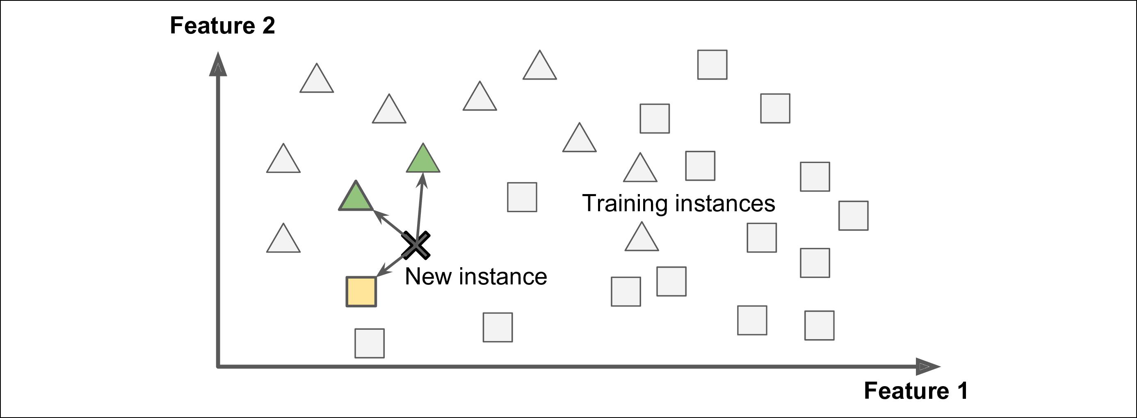

*Figure 1-15. Instance-based learning/ Học dựa trên cái thể*

**Model-based learning/ Học dựa trên mô hình**

Another way to generalize from a set of examples is to build a model of these examples, then use that model to make *predictions*. This is called *model-based learning* (Figure 1-16).

Một cách khác để khái quát hóa từ những ví dụ là xây dựng một mô hình của các ví dụ này, sau đó sử dụng mô hình đó để dự đoán. Nó được gọi là học dựa trên mô hình.

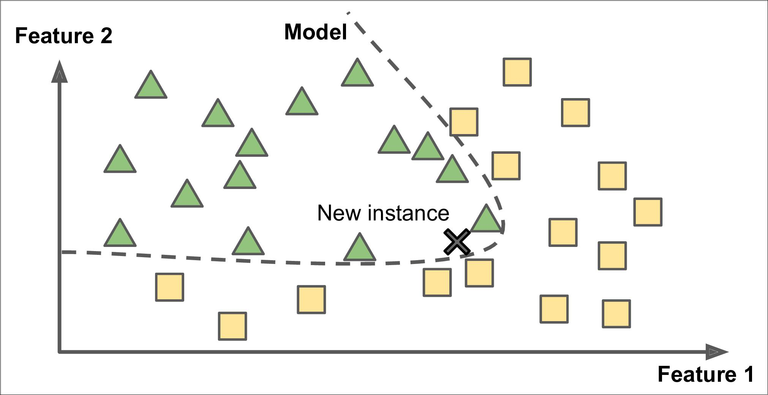

*Figure 1-16. Model-based learning/Học dựa trên mô hình*

For example, suppose you want to know if money makes people happy, so you download the *Better Life Index* data from the [OECD’s website](https://homl.info/4) as well as stats about GDP per capita from the [IMF’s website](https://homl.info/5) . Then you join the tables and sort by GDP per cap‐ ita. Table 1-1 shows an excerpt of what you get.

Ví dụ, giả sử bạn muốn biết nếu tiền có làm cho mọi người hạnh phúc, vậy bạn dữ liệu Better Life Index từ website OECD cũng như các số liệu thống kê GDP bình quân đầu người từ website IMF. Bảng 1-1 là đoạn trích về những gì bạn nhận được.



**Types of Machine Learning Systems** **|** **19**

*Table 1-1. Does money make people happier?/Tiền có làm mọi người hạnh phúc*

|  |  |  |
| --- | --- | --- |
| **Country** | **GDP per capita (USD)** | **Life satisfaction** |
| Hungary | 12,240 | 4.9 |
| Korea | 27,195 | 5.8 |
| France | 37,675 | 6.5 |
| Australia | 50,962 | 7.3 |
| United States | 55,805 | 7.2 |
|  |  |  |

Let’s plot the data for a few random countries (Figure 1-17).

Hãy thử ngẫu nhiên dữ liệu ở các quốc gia.

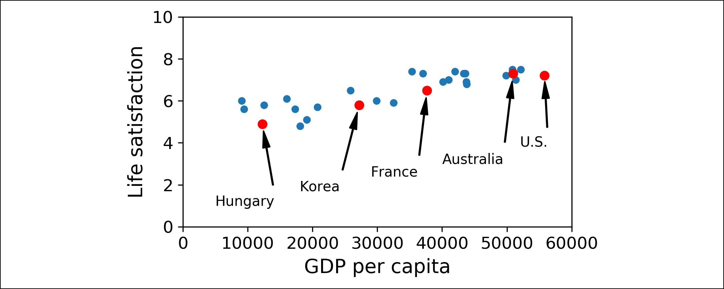

*Figure 1-17. Do you see a trend here?/ Bạn thấy xu hướng của chúng không?*

There does seem to be a trend here! Although the data is *noisy* (i.e., partly random), it looks like life satisfaction goes up more or less linearly as the country’s GDP per cap‐ ita increases. So you decide to model life satisfaction as a linear function of GDP per capita. This step is called *model selection*: you selected a *linear model* of life satisfac‐ tion with just one attribute, GDP per capita (Equation 1-1).

Có thể thấy xu hướng tại đây! Mặc dù dữ liệu có nhiễu(tức là một phần là ngẫu nhiên), có vẻ sự hài lòng về cuộc sống tăng lên tuyến tính nhiều hoặc ít theo GDP bình quần đầu người của các quốc gia. Bạn quyết định mô hình hóa sự hài lòng về cuộc sống là một hàm tuyến tính của GDP đầu người. Tiếp đó được gọi là chọn mô hình: bạn đã chọn một mô hình tuyến tính của sự hài lòng về cuộc sống với chỉ một thuộc tính, GDP đầu người.(công thức 1-1).

*Equation 1-1. A simple linear model*

*Công thức 1-1. Mô hình tuyến tính đơn giản*

life_satisfaction = *θ*0 + *θ*1×GDP_per_capita

This model has two *model parameters*, *θ*0 and *θ*1.5 By tweaking these parameters, you can make your model represent any linear function, as shown in Figure 1-18.

Trong mô hình có 2 tham số *θ*0 và *θ*1. Bằng cách điều chỉnh các tham số này, bạn có thể làm cho mô hình của bạn đại diện cho bất kỳ hàm tuyến tính nào, như hình 1-18.

5 By convention, the Greek letter θ (theta) is frequently used to represent model parameters./ Quy ước, ký hiệu Hy lạp θ (theta) thường được sử dụng để đại diện cho các tham số của mô hình.



**20** **|** **Chapter 1: The Machine Learning Landscape**

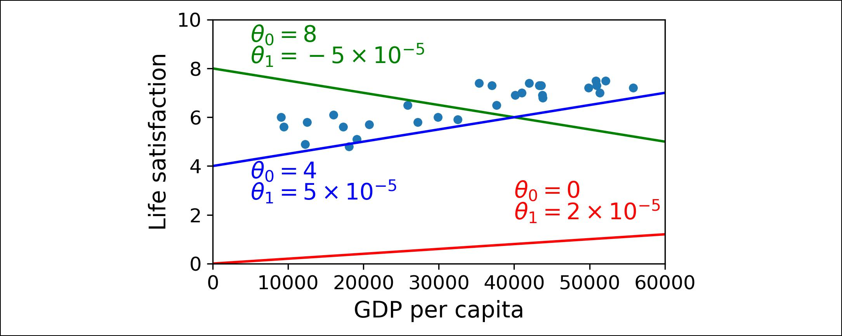

*Figure 1-18. A few possible linear models/Một vài mô hình tuyến tính*

Before you can use your model, you need to define the parameter values *θ*0 and *θ*1. How can you know which values will make your model perform best? To answer this question, you need to specify a performance measure. You can either define a *utility* *function* (or *fitness function*) that measures how *good* your model is, or you can definea *cost function* that measures how *bad* it is. For linear regression problems, people typically use a cost function that measures the distance between the linear model’s predictions and the training examples; the objective is to minimize this distance.

Trước khi bạn sử dụng mô hình của mình, bạn cần định nghĩa các giá trị *θ*0 và *θ*1. Làm thế nào để bạn có thể biết giá trị nào sẽ làm cho mô hình của bạn hoạt động tốt? Đây là câu trả lời, bạn cần chỉ định một phép đo hiệu suất, bạn có thể định nghĩa ra một hàm lợi ích(hoặc hàm thích nghi) để đo lường tốt mô hình của bạn, hoặc bạn có thể định nghĩa một hàm chi phí để đo lường nó tệ như nào. Đối với vấn đề hồi quy tuyến tính, mọi người thường sử dụng hàm chi phí để đo khoảng cách giữa mô hình dự đoán tuyến tính với các ví dụ huấn luyện. Mục tiêu là để giảm thiểu khoảng cách này.

This is where the Linear Regression algorithm comes in: you feed it your training examples and it finds the parameters that make the linear model fit best to your data. This is called *training* the model. In our case the algorithm finds that the optimal parameter values are *θ*0 = 4.85 and *θ*1 = 4.91 × 10–5.

Đây là cách thuật toán hồi quy tuyến tính xuất hiện: bạn cung cấp cho nó những ví dụ huấn luyện và nó sẽ tìm các tham số để làm cho mô hình tuyến tính của bạn phù hợp nhất với dữ liệu của bạn. Nó được gọi là huấn luyện mô hình. Trong trường hợp của chúng tôi thuật toán tìm ra tham số tối ưu là *θ*0 = 4.85 và *θ*1 = 4.91 × 10–5.

Now the model fits the training data as closely as possible (for a linear model), as you can see in Figure 1-19.

Bây giờ mô hình đã fit với dữ liệu được huấn luyện gần nhất có thể(với mô hình tuyến tính), như bạn có thể thấy hình 1-19.

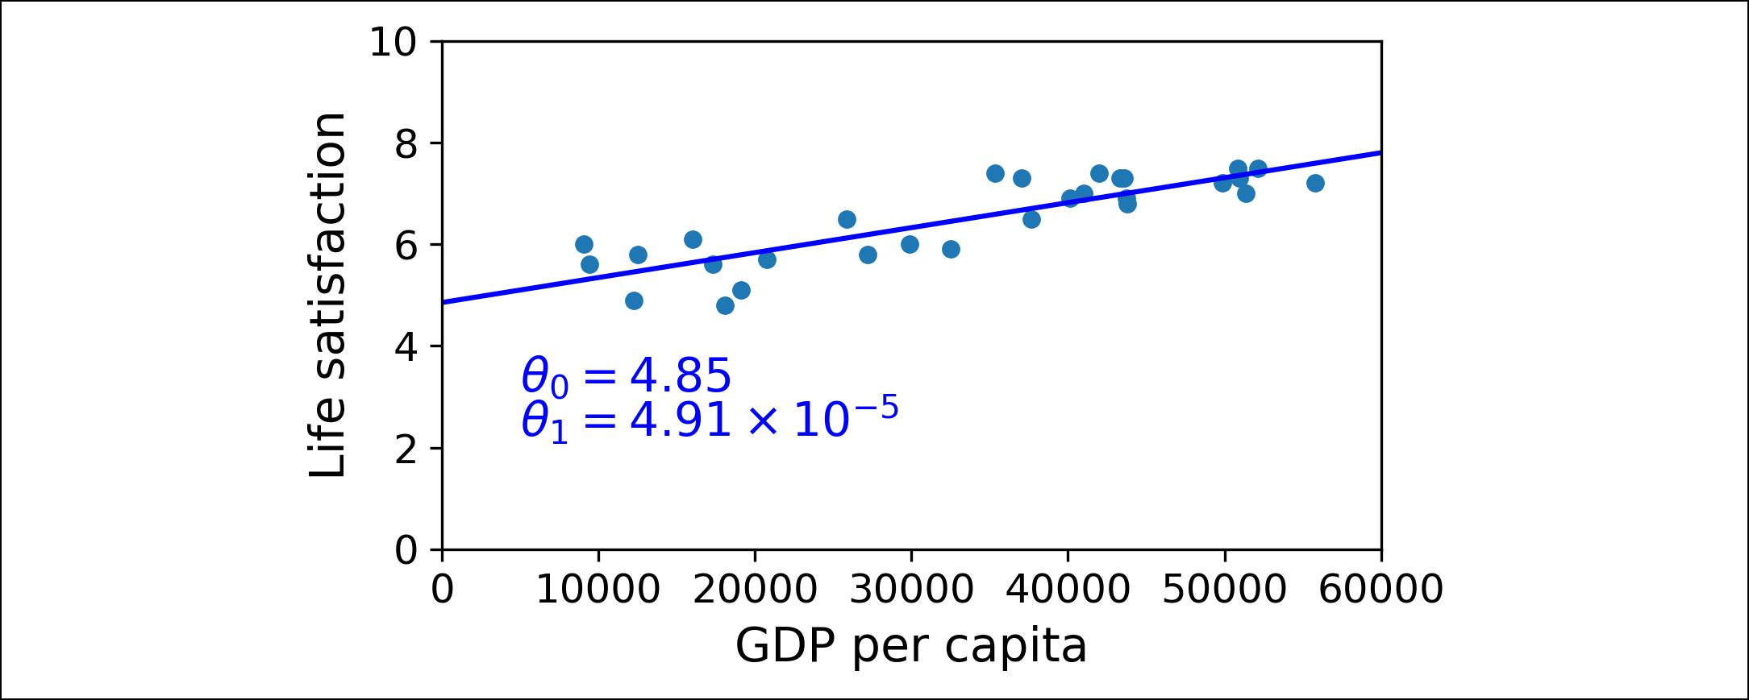

*Figure 1-19. The linear model that fits the training data best/Mô hình tuyến tính phù hợp nhất với dữ liệu huấn luyện*



**Types of Machine Learning Systems** **|** **21**

You are finally ready to run the model to make predictions. For example, say you want to know how happy Cypriots are, and the OECD data does not have the answer. Fortunately, you can use your model to make a good prediction: you look up Cyprus’s GDP per capita, find $22,587, and then apply your model and find that life satisfac‐ tion is likely to be somewhere around 4.85 + 22,587 × 4.91 × 10-5 = 5.96.

To whet your appetite, Example 1-1 shows the Python code that loads the data, pre‐ pares it, 6 creates a scatterplot for visualization, and then trains a linear model and makes a prediction.7

Cuối cùng bạn đã sẵn sàng để chạy được mô hình dự đoán. Ví dụ, bạn nói muốn biết người Cypriots hạnh phúc như thế nào, và dữ liệu OECD không có câu trả lời. May mắn thay, bạn có thể sự dụng mô hình của bạn để dự đoán tốt: bạn nhìn thấy GDP bình quân của Cyprus là 22,587$ và sau đó bạn cho nó vào mô hình của bạn và tìm điểm thỏa mãn về cuộc sống nằm khoảng 4.85 + 22,587 × 4.91 × 10-5 = 5.96

*Example 1-1. Training and running a linear model using Scikit-Learn/Huấn luyện và chạy mô hình tuyến tính sử dụng Scikit-learn*

**import matplotlib.pyplot as plt import numpy as np**

**import pandas as pd**

**import sklearn.linear_model**

*# Load the data*

oecd_bli = pd.read_csv("oecd_bli_2015.csv", thousands=',')

gdp_per_capita = pd.read_csv("gdp_per_capita.csv",thousands=',',delimiter='**\t**', encoding='latin1', na_values="n/a")

*# Prepare the data*

country_stats = prepare_country_stats(oecd_bli, gdp_per_capita) X = np.c_[country_stats["GDP per capita"]]

y = np.c_[country_stats["Life satisfaction"]]

*# Visualize the data*

country_stats.plot(kind='scatter', x="GDP per capita", y='Life satisfaction') plt.show()

*# Select a linear model*

model = sklearn.linear_model.LinearRegression()

* *Train the model* model.fit(X, y)
* *Make a prediction for Cyprus*

X_new = [[22587]] *# Cyprus' GDP per capita* **print**(model.predict(X_new))*# outputs [[ 5.96242338]]*



1. The prepare_country_stats() function’s definition is not shown here (see this chapter’s Jupyter notebook if you want all the gory details). It’s just boring Pandas code that joins the life satisfaction data from the OECD with the GDP per capita data from the IMF.
2. It’s okay if you don’t understand all the code yet; we will present Scikit-Learn in the following chapters.



**22** **|** **Chapter 1: The Machine Learning Landscape**

If you had used an instance-based learning algorithm instead, you would have found that Slovenia has the closest GDP per capita to that of Cyprus ($20,732), and since the OECD data tells us that Slovenians’ life satisfaction is 5.7, you would have predicted a life satisfaction of 5.7 for Cyprus. If you zoom out a bit and look at the two next closest countries, you will find Portugal and Spain with life satisfactions of 5.1 and 6.5, respectively. Averaging these three values, you get 5.77, which is pretty close to your model-based pre‐ diction. This simple algorithm is called *k-Nearest Neighbors* regres‐ sion (in this example, *k* = 3).



Replacing the Linear Regression model with k-Nearest Neighbors regression in the previous code is as simple as replacing these two lines:

**import sklearn.linear_model**

model = sklearn.linear_model.LinearRegression() with these two:

**import sklearn.neighbors**

model = sklearn.neighbors.KNeighborsRegressor(n_neighbors=3)

If all went well, your model will make good predictions. If not, you may need to use more attributes (employment rate, health, air pollution, etc.), get more or better qual‐ ity training data, or perhaps select a more powerful model (e.g., a Polynomial Regres‐ sion model).

In summary:

* You studied the data.
* You selected a model.
* You trained it on the training data (i.e., the learning algorithm searched for the model parameter values that minimize a cost function).
* Finally, you applied the model to make predictions on new cases (this is called *inference*), hoping that this model will generalize well.

This is what a typical Machine Learning project looks like. In Chapter 2 you will experience this first-hand by going through an end-to-end project.

We have covered a lot of ground so far: you now know what Machine Learning is really about, why it is useful, what some of the most common categories of ML sys‐ tems are, and what a typical project workflow looks like. Now let’s look at what can go wrong in learning and prevent you from making accurate predictions.



**Types of Machine Learning Systems** **|** **23**

**Main Challenges of Machine Learning**

In short, since your main task is to select a learning algorithm and train it on some data, the two things that can go wrong are “bad algorithm” and “bad data.” Let’s start with examples of bad data.

**Insufficient Quantity of Training Data**

For a toddler to learn what an apple is, all it takes is for you to point to an apple and say “apple” (possibly repeating this procedure a few times). Now the child is able to recognize apples in all sorts of colors and shapes. Genius.

Machine Learning is not quite there yet; it takes a lot of data for most Machine Learn‐ ing algorithms to work properly. Even for very simple problems you typically need thousands of examples, and for complex problems such as image or speech recogni‐ tion you may need millions of examples (unless you can reuse parts of an existing model).



**24** **|** **Chapter 1: The Machine Learning Landscape**

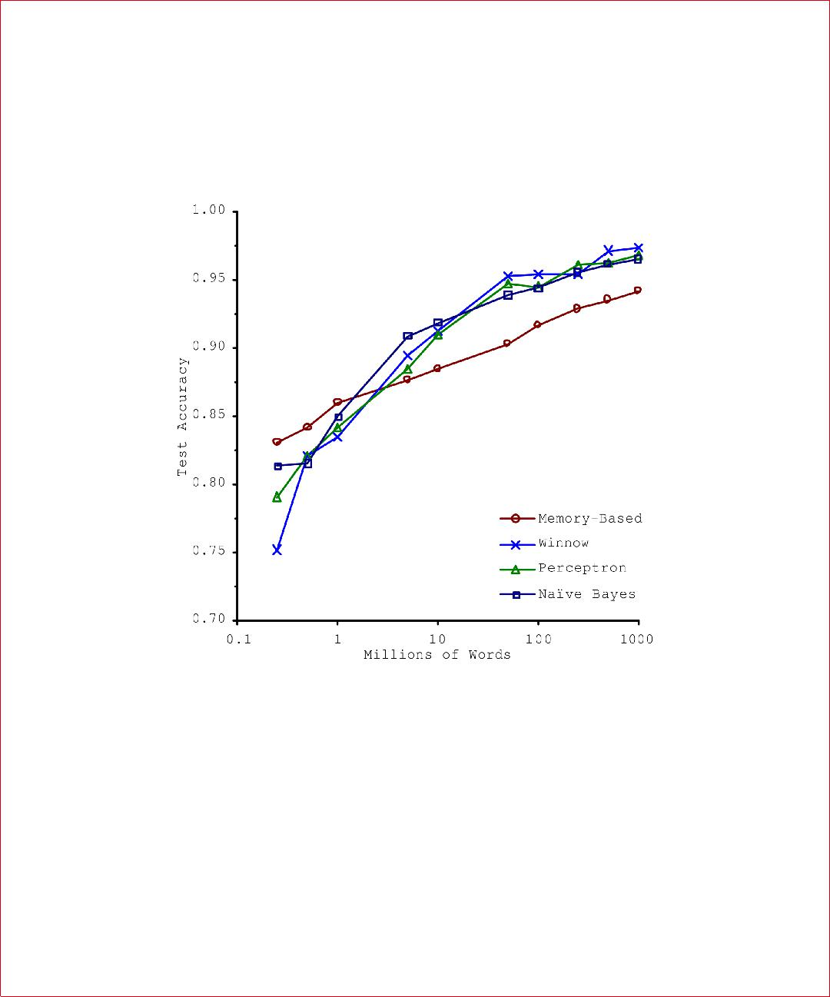**The Unreasonable Effectiveness of Data**

In a [famous paper](https://homl.info/6) published in 2001, Microsoft researchers Michele Banko and Eric Brill showed that very different Machine Learning algorithms, including fairly simple ones, performed almost identically well on a complex problem of natural language disambiguation8 once they were given enough data (as you can see in Figure 1-20).

*Figure 1-20. The importance of data versus algorithms**9*

As the authors put it: “these results suggest that we may want to reconsider the trade-off between spending time and money on algorithm development versus spending it on corpus development.”

The idea that data matters more than algorithms for complex problems was further popularized by Peter Norvig et al. in a paper titled [“The Unreasonable Effectiveness](https://homl.info/7) [of Data”](https://homl.info/7) published in 2009.10 It should be noted, however, that small- and medium-sized datasets are still very common, and it is not always easy or cheap to get extra training data, so don’t abandon algorithms just yet.



1. For example, knowing whether to write “to,” “two,” or “too” depending on the context.
2. Figure reproduced with permission from Banko and Brill (2001), “Learning Curves for Confusion Set Disam‐ biguation.”
3. “The Unreasonable Effectiveness of Data,” Peter Norvig et al. (2009).



**Main Challenges of Machine Learning** **|** **25**

**Nonrepresentative Training Data**

In order to generalize well, it is crucial that your training data be representative of the new cases you want to generalize to. This is true whether you use instance-based learning or model-based learning.

For example, the set of countries we used earlier for training the linear model was not perfectly representative; a few countries were missing. Figure 1-21 shows what the data looks like when you add the missing countries.

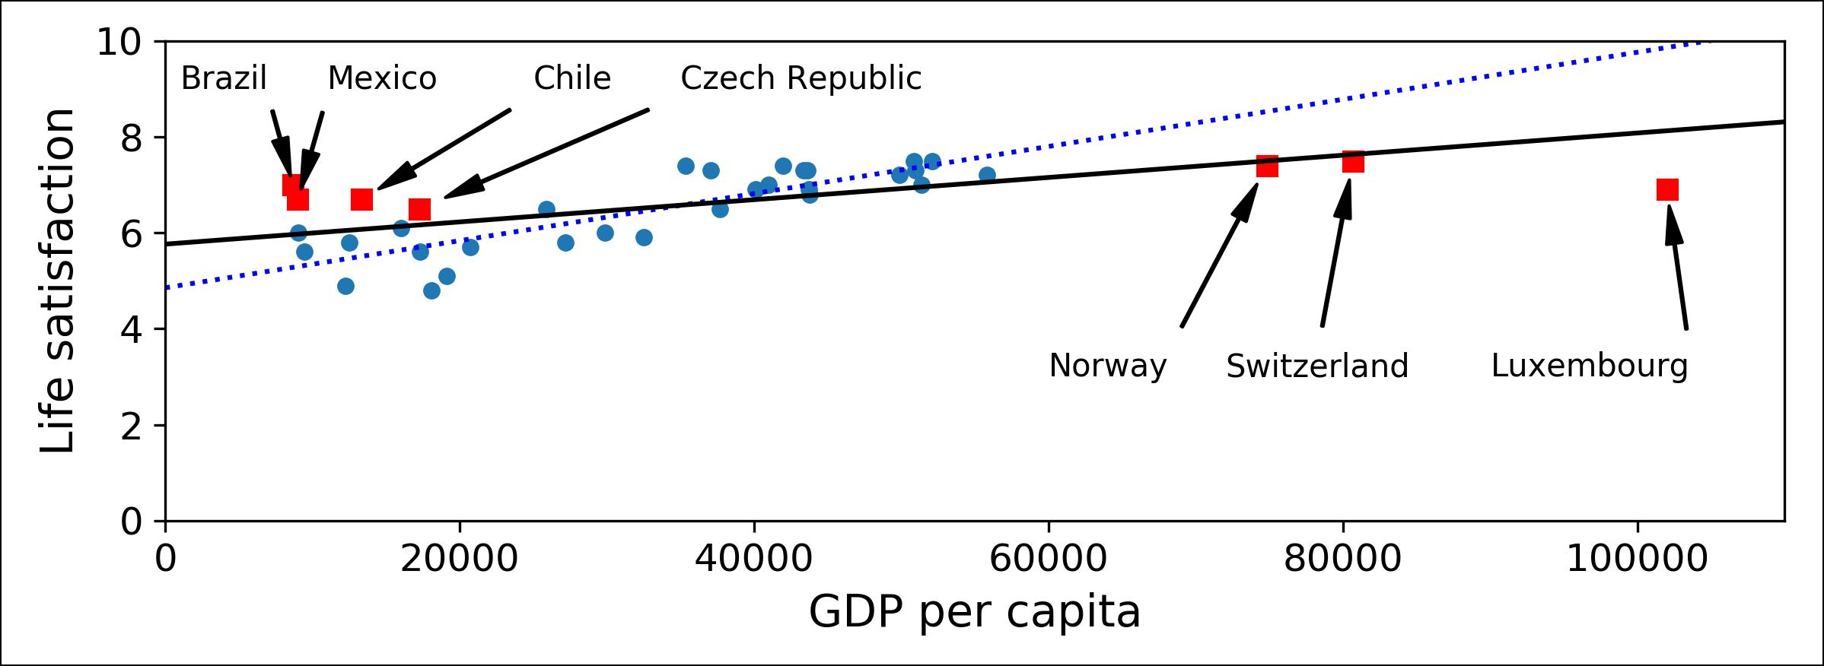

*Figure 1-21. A more representative training sample*

If you train a linear model on this data, you get the solid line, while the old model is represented by the dotted line. As you can see, not only does adding a few missing countries significantly alter the model, but it makes it clear that such a simple linear model is probably never going to work well. It seems that very rich countries are not happier than moderately rich countries (in fact they seem unhappier), and conversely some poor countries seem happier than many rich countries.

By using a nonrepresentative training set, we trained a model that is unlikely to make accurate predictions, especially for very poor and very rich countries.

It is crucial to use a training set that is representative of the cases you want to general‐ ize to. This is often harder than it sounds: if the sample is too small, you will have *sampling noise* (i.e., nonrepresentative data as a result of chance), but even very largesamples can be nonrepresentative if the sampling method is flawed. This is called *sampling bias*.



**A Famous Example of Sampling Bias**

Perhaps the most famous example of sampling bias happened during the US presi‐ dential election in 1936, which pitted Landon against Roosevelt: the *Literary Digest* conducted a very large poll, sending mail to about 10 million people. It got 2.4 million answers, and predicted with high confidence that Landon would get 57% of the votes.



**26** **|** **Chapter 1: The Machine Learning Landscape**

Instead, Roosevelt won with 62% of the votes. The flaw was in the *Literary Digest*’s sampling method:



* First, to obtain the addresses to send the polls to, the *Literary Digest* used tele‐ phone directories, lists of magazine subscribers, club membership lists, and the like. All of these lists tend to favor wealthier people, who are more likely to vote Republican (hence Landon).
* Second, less than 25% of the people who received the poll answered. Again, this introduces a sampling bias, by ruling out people who don’t care much about poli‐ tics, people who don’t like the *Literary Digest*, and other key groups. This is a spe‐ cial type of sampling bias called *nonresponse bias*.

Here is another example: say you want to build a system to recognize funk music vid‐ eos. One way to build your training set is to search “funk music” on YouTube and use the resulting videos. But this assumes that YouTube’s search engine returns a set of videos that are representative of all the funk music videos on YouTube. In reality, the search results are likely to be biased toward popular artists (and if you live in Brazil you will get a lot of “funk carioca” videos, which sound nothing like James Brown). On the other hand, how else can you get a large training set?

**Poor-Quality Data**

Obviously, if your training data is full of errors, outliers, and noise (e.g., due to poor-quality measurements), it will make it harder for the system to detect the underlying patterns, so your system is less likely to perform well. It is often well worth the effort to spend time cleaning up your training data. The truth is, most data scientists spend a significant part of their time doing just that. For example:

* If some instances are clearly outliers, it may help to simply discard them or try to fix the errors manually.
* If some instances are missing a few features (e.g., 5% of your customers did not specify their age), you must decide whether you want to ignore this attribute alto‐ gether, ignore these instances, fill in the missing values (e.g., with the median age), or train one model with the feature and one model without it, and so on.

**Irrelevant Features**

As the saying goes: garbage in, garbage out. Your system will only be capable of learn‐ ing if the training data contains enough relevant features and not too many irrelevant ones. A critical part of the success of a Machine Learning project is coming up with a good set of features to train on. This process, called *feature engineering*, involves:



**Main Challenges of Machine Learning** **|** **27**

* *Feature selection*: selecting the most useful features to train on among existingfeatures.
* *Feature extraction*: combining existing features to produce a more useful one (aswe saw earlier, dimensionality reduction algorithms can help).
* Creating new features by gathering new data.

Now that we have looked at many examples of bad data, let’s look at a couple of exam‐ ples of bad algorithms.

**Over€tting the Training Data**

Say you are visiting a foreign country and the taxi driver rips you off. You might be tempted to say that *all* taxi drivers in that country are thieves. Overgeneralizing is something that we humans do all too often, and unfortunately machines can fall into the same trap if we are not careful. In Machine Learning this is called *overfitting*: it means that the model performs well on the training data, but it does not generalize well.

Figure 1-22 shows an example of a high-degree polynomial life satisfaction model that strongly overfits the training data. Even though it performs much better on the training data than the simple linear model, would you really trust its predictions?

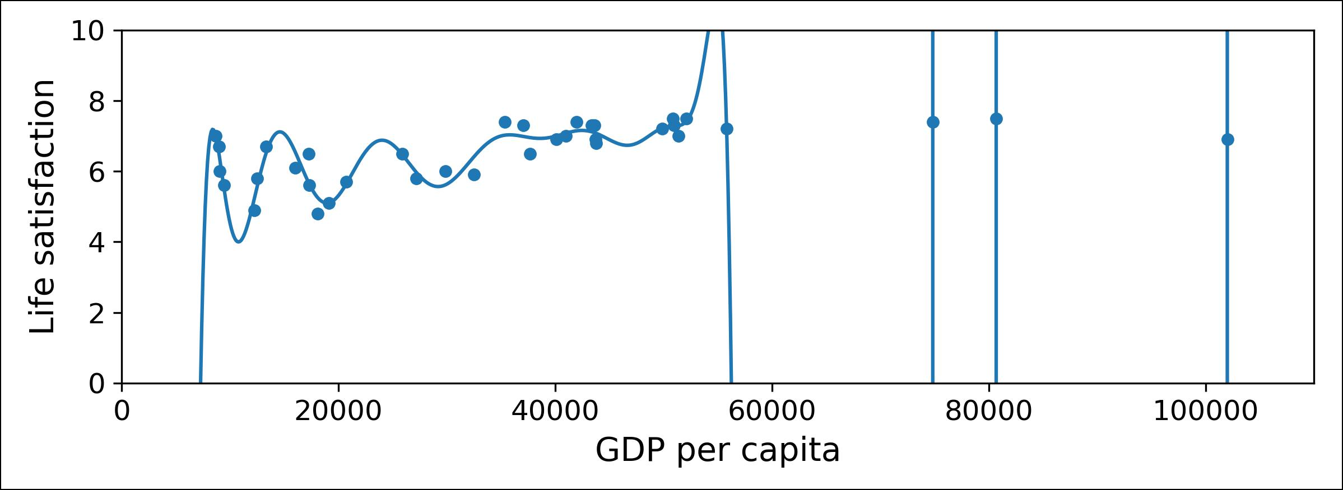

*Figure 1-22. Overfitting the training data*

Complex models such as deep neural networks can detect subtle patterns in the data, but if the training set is noisy, or if it is too small (which introduces sampling noise), then the model is likely to detect patterns in the noise itself. Obviously these patterns will not generalize to new instances. For example, say you feed your life satisfaction model many more attributes, including uninformative ones such as the country’s name. In that case, a complex model may detect patterns like the fact that all coun‐ tries in the training data with a *w* in their name have a life satisfaction greater than 7: New Zealand (7.3), Norway (7.4), Sweden (7.2), and Switzerland (7.5). How confident



**28** **|** **Chapter 1: The Machine Learning Landscape**

are you that the W-satisfaction rule generalizes to Rwanda or Zimbabwe? Obviously this pattern occurred in the training data by pure chance, but the model has no way to tell whether a pattern is real or simply the result of noise in the data.

Overfitting happens when the model is too complex relative to the amount and noisiness of the training data. The possible solutions are:



* To simplify the model by selecting one with fewer parameters (e.g., a linear model rather than a high-degree polynomial model), by reducing the number of attributes in the training data or by constraining the model
* To gather more training data
* To reduce the noise in the training data (e.g., fix data errors and remove outliers)

Constraining a model to make it simpler and reduce the risk of overfitting is called *regularization*. For example, the linear model we defined earlier has two parameters, *θ*0and *θ*1. This gives the learning algorithm two *degrees of freedom* to adapt the modelto the training data: it can tweak both the height (*θ*0) and the slope (*θ*1) of the line. If we forced *θ*1 = 0, the algorithm would have only one degree of freedom and would have a much harder time fitting the data properly: all it could do is move the line up or down to get as close as possible to the training instances, so it would end up around the mean. A very simple model indeed! If we allow the algorithm to modify *θ*1 but we force it to keep it small, then the learning algorithm will effectively have some‐ where in between one and two degrees of freedom. It will produce a simpler model than with two degrees of freedom, but more complex than with just one. You want to find the right balance between fitting the training data perfectly and keeping the model simple enough to ensure that it will generalize well.

Figure 1-23 shows three models: the dotted line represents the original model that was trained with a few countries missing, the dashed line is our second model trained with all countries, and the solid line is a linear model trained with the same data as the first model but with a regularization constraint. You can see that regularization forced the model to have a smaller slope, which fits a bit less the training data that the model was trained on, but actually allows it to generalize better to new examples.



**Main Challenges of Machine Learning** **|** **29**

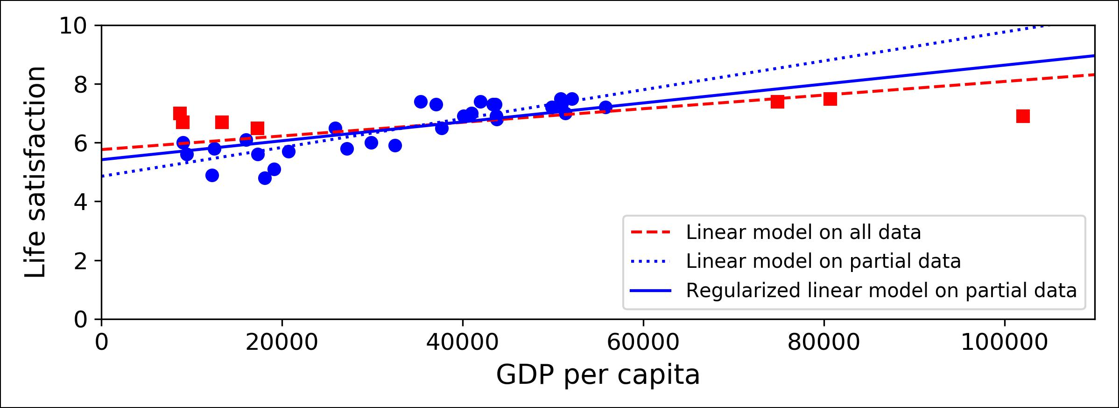

*Figure 1-23. Regularization reduces the risk of overfitting*

The amount of regularization to apply during learning can be controlled by a *hyper‐* *parameter*. A hyperparameter is a parameter of a learning algorithm (not of themodel). As such, it is not affected by the learning algorithm itself; it must be set prior to training and remains constant during training. If you set the regularization hyper‐ parameter to a very large value, you will get an almost flat model (a slope close to zero); the learning algorithm will almost certainly not overfit the training data, but it will be less likely to find a good solution. Tuning hyperparameters is an important part of building a Machine Learning system (you will see a detailed example in the next chapter).

**Under€tting the Training Data**

As you might guess, *underfitting* is the opposite of overfitting: it occurs when your model is too simple to learn the underlying structure of the data. For example, a lin‐ ear model of life satisfaction is prone to underfit; reality is just more complex than the model, so its predictions are bound to be inaccurate, even on the training exam‐ ples.

The main options to fix this problem are:

* Selecting a more powerful model, with more parameters
* Feeding better features to the learning algorithm (feature engineering)
* Reducing the constraints on the model (e.g., reducing the regularization hyper‐ parameter)

**Stepping Back**

By now you already know a lot about Machine Learning. However, we went through so many concepts that you may be feeling a little lost, so let’s step back and look at the big picture:



**30** **|** **Chapter 1: The Machine Learning Landscape**

* Machine Learning is about making machines get better at some task by learning from data, instead of having to explicitly code rules.
* There are many different types of ML systems: supervised or not, batch or online, instance-based or model-based, and so on.
* In a ML project you gather data in a training set, and you feed the training set to a learning algorithm. If the algorithm is model-based it tunes some parameters to fit the model to the training set (i.e., to make good predictions on the training set itself), and then hopefully it will be able to make good predictions on new cases as well. If the algorithm is instance-based, it just learns the examples by heart and generalizes to new instances by comparing them to the learned instances using a similarity measure.
* The system will not perform well if your training set is too small, or if the data is not representative, noisy, or polluted with irrelevant features (garbage in, garbage out). Lastly, your model needs to be neither too simple (in which case it will underfit) nor too complex (in which case it will overfit).

There’s just one last important topic to cover: once you have trained a model, you don’t want to just “hope” it generalizes to new cases. You want to evaluate it, and fine-tune it if necessary. Let’s see how.

**Testing and Validating**

The only way to know how well a model will generalize to new cases is to actually try it out on new cases. One way to do that is to put your model in production and moni‐ tor how well it performs. This works well, but if your model is horribly bad, your users will complain—not the best idea.

A better option is to split your data into two sets: the *training set* and the *test set*. As these names imply, you train your model using the training set, and you test it using the test set. The error rate on new cases is called the *generalization error* (or *out-of-sample error*), and by evaluating your model on the test set, you get an estimate of thiserror. This value tells you how well your model will perform on instances it has never seen before.

If the training error is low (i.e., your model makes few mistakes on the training set) but the generalization error is high, it means that your model is overfitting the train‐ ing data.



It is common to use 80% of the data for training and *hold out* 20% for testing. However, this depends on the size of the dataset: if it contains 10 million instances, then holding out 1% means your test set will contain 100,000 instances: that’s probably more than enough to get a good estimate of the generalization error.



**Testing and Validating** **|** **31**

**Hyperparameter Tuning and Model Selection**

So evaluating a model is simple enough: just use a test set. Now suppose you are hesi‐ tating between two models (say a linear model and a polynomial model): how can you decide? One option is to train both and compare how well they generalize using the test set.

Now suppose that the linear model generalizes better, but you want to apply some regularization to avoid overfitting. The question is: how do you choose the value of the regularization hyperparameter? One option is to train 100 different models using 100 different values for this hyperparameter. Suppose you find the best hyperparame‐ ter value that produces a model with the lowest generalization error, say just 5% error.

So you launch this model into production, but unfortunately it does not perform as well as expected and produces 15% errors. What just happened?

The problem is that you measured the generalization error multiple times on the test set, and you adapted the model and hyperparameters to produce the best model *for* *that particular set*. This means that the model is unlikely to perform as well on newdata.

A common solution to this problem is called *holdout validation*: you simply hold out part of the training set to evaluate several candidate models and select the best one. The new heldout set is called the *validation set* (or sometimes the *development set*, or *dev set*). More specifically, you train multiple models with various hyperparameterson the reduced training set (i.e., the full training set minus the validation set), and you select the model that performs best on the validation set. After this holdout vali‐ dation process, you train the best model on the full training set (including the valida‐ tion set), and this gives you the final model. Lastly, you evaluate this final model on the test set to get an estimate of the generalization error.

This solution usually works quite well. However, if the validation set is too small, then model evaluations will be imprecise: you may end up selecting a suboptimal model by mistake. Conversely, if the validation set is too large, then the remaining training set will be much smaller than the full training set. Why is this bad? Well, since the final model will be trained on the full training set, it is not ideal to compare candidate models trained on a much smaller training set. It would be like selecting the fastest sprinter to participate in a marathon. One way to solve this problem is to perform repeated *cross-validation*, using many small validation sets. Each model is evaluated once per validation set, after it is trained on the rest of the data. By averaging out all the evaluations of a model, we get a much more accurate measure of its performance. However, there is a drawback: the training time is multiplied by the number of valida‐ tion sets.

**32** **|** **Chapter 1: The Machine Learning Landscape**

**Data Mismatch**

In some cases, it is easy to get a large amount of data for training, but it is not per‐ fectly representative of the data that will be used in production. For example, suppose you want to create a mobile app to take pictures of flowers and automatically deter‐ mine their species. You can easily download millions of pictures of flowers on the web, but they won’t be perfectly representative of the pictures that will actually be taken using the app on a mobile device. Perhaps you only have 10,000 representative pictures (i.e., actually taken with the app). In this case, the most important rule to remember is that the validation set and the test must be as representative as possible of the data you expect to use in production, so they should be composed exclusively of representative pictures: you can shuffle them and put half in the validation set, and half in the test set (making sure that no duplicates or near-duplicates end up in both sets). After training your model on the web pictures, if you observe that the perfor‐ mance of your model on the validation set is disappointing, you will not know whether this is because your model has overfit the training set, or whether this is just due to the mismatch between the web pictures and the mobile app pictures. One sol‐ ution is to hold out part of the training pictures (from the web) in yet another set that Andrew Ng calls the *train-dev set*. After the model is trained (on the training set, *not* on the train-dev set), you can evaluate it on the train-dev set: if it performs well, then the model is not overfitting the training set, so if performs poorly on the validation set, the problem must come from the data mismatch. You can try to tackle this prob‐ lem by preprocessing the web images to make them look more like the pictures that will be taken by the mobile app, and then retraining the model. Conversely, if the model performs poorly on the train-dev set, then the model must have overfit the training set, so you should try to simplify or regularize the model, get more training data and clean up the training data, as discussed earlier.



**No Free Lunch Theorem**

A model is a simplified version of the observations. The simplifications are meant to discard the superfluous details that are unlikely to generalize to new instances. How‐ ever, to decide what data to discard and what data to keep, you must make *assump‐* *tions*. For example, a linear model makes the assumption that the data isfundamentally linear and that the distance between the instances and the straight line is just noise, which can safely be ignored.

In a [famous 1996 paper](https://homl.info/8),11 David Wolpert demonstrated that if you make absolutely no assumption about the data, then there is no reason to prefer one model over any other. This is called the *No Free Lunch* (NFL) theorem. For some datasets the best



11 “The Lack of A Priori Distinctions Between Learning Algorithms,” D. Wolpert (1996).



**Testing and Validating** **|** **33**

model is a linear model, while for other datasets it is a neural network. There is no model that is *a priori* guaranteed to work better (hence the name of the theorem). The only way to know for sure which model is best is to evaluate them all. Since this is not possible, in practice you make some reasonable assumptions about the data and you evaluate only a few reasonable models. For example, for simple tasks you may evalu‐ ate linear models with various levels of regularization, and for a complex problem you may evaluate various neural networks.



**Exercises**

In this chapter we have covered some of the most important concepts in Machine Learning. In the next chapters we will dive deeper and write more code, but before we do, make sure you know how to answer the following questions:

1. How would you define Machine Learning?
2. Can you name four types of problems where it shines?
3. What is a labeled training set?
4. What are the two most common supervised tasks?
5. Can you name four common unsupervised tasks?
6. What type of Machine Learning algorithm would you use to allow a robot to walk in various unknown terrains?
7. What type of algorithm would you use to segment your customers into multiple groups?
8. Would you frame the problem of spam detection as a supervised learning prob‐ lem or an unsupervised learning problem?
9. What is an online learning system?
10. What is out-of-core learning?
11. What type of learning algorithm relies on a similarity measure to make predic‐ tions?
12. What is the difference between a model parameter and a learning algorithm’s hyperparameter?
13. What do model-based learning algorithms search for? What is the most common strategy they use to succeed? How do they make predictions?
14. Can you name four of the main challenges in Machine Learning?
15. If your model performs great on the training data but generalizes poorly to new instances, what is happening? Can you name three possible solutions?
16. What is a test set and why would you want to use it?



**34** **|** **Chapter 1: The Machine Learning Landscape**

1. What is the purpose of a validation set?
2. What can go wrong if you tune hyperparameters using the test set?
3. What is repeated cross-validation and why would you prefer it to using a single validation set?

Solutions to these exercises are available in ???.



**Exercises** **|** **35**